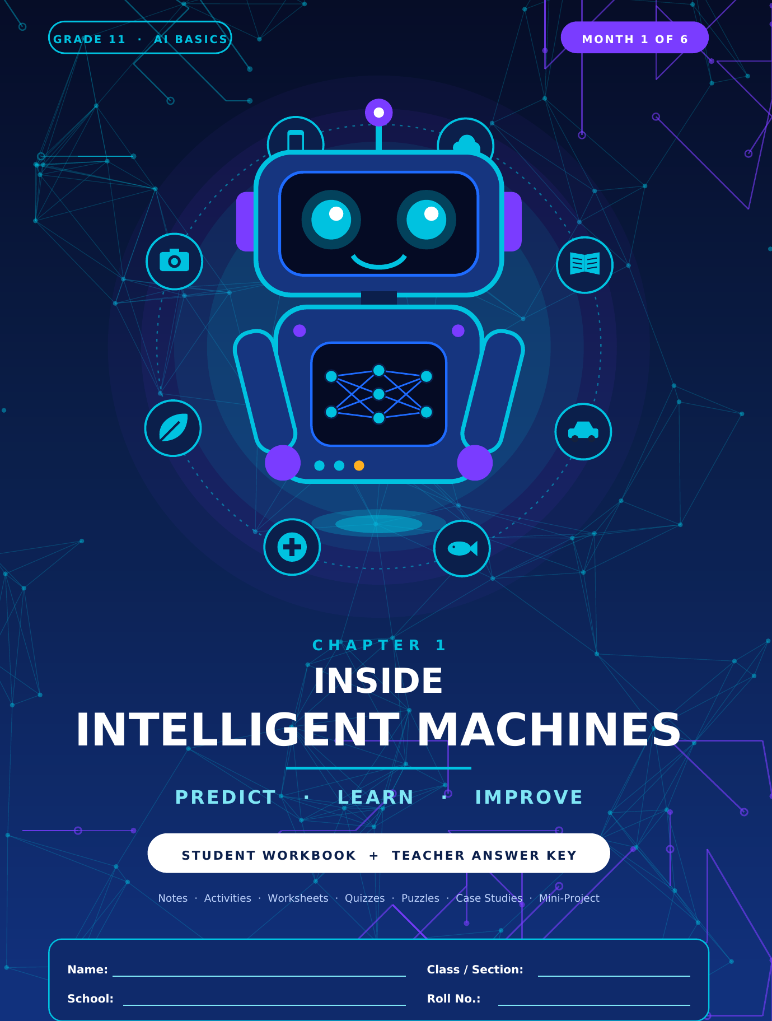

0 Welcome and Contents
Grade 11 AI Basics · Month 1 · Chapter 1
ABOUT THIS WORKBOOK
This workbook covers Month 1 only (Chapter 1: Inside Intelligent Machines: Predict, Learn and Improve). By the end you will be able to: explain what AI is; describe data, features, labels and patterns; explain how machine learning uses training and testing data; calculate accuracy; describe how errors, bias and poor data affect AI; and discuss AI in real-life fields responsibly. No programming or internet is needed.

Part A · Learn: Chapter Notes 4
A1 What Is Artificial Intelligence? 5
A2 Data, Datasets, Labels, Features and Patterns 8
A3 How AI Learns: Machine Learning 10
A4 Training Data, Testing Data, Models and Predictions 12
A5 How AI Makes Choices 14
A6 Worked Example: AI Classifying Fruits 16
A7 Accuracy, Incorrect Predictions and Data Quality 19
A8 Bias, Fairness, Privacy and Responsible AI 21
A9 AI in the Real World 23
A10 Chapter Summary, Concept Map and Glossary 25
Part B · Do: Classroom Activities 27
B1 Activity 1: Human vs AI Classification 28
B2 Activity 2: Build a Mini Dataset 30
B3 Activity 3: Train a Classroom Classifier 32
B4 Activity 4: Identify Bias in a Dataset 34
B5 Activity 5: Draw an AI Decision-Making Flowchart 36
Part C · Practise: Worksheets 38
W1 Worksheet 1: AI and Data Basics 39
W2 Worksheet 2: Learning from Data and Making Predictions 41
W3 Worksheet 3: AI Errors, Bias and Responsible AI 43
Part D · Check: MCQs, Quiz and Assessment 45
D1 Multiple-Choice Questions 46
D2 Quick Quiz 49
D3 Chapter 1 Assessment 50
Part E · Play: Puzzles and Brain Games 53
E1 Puzzle 1: AI and Data Word Search 54
E2 Puzzle 2: Match AI Terms with Their Meanings 55
E3 Puzzle 3: Find the Pattern Challenge 56

E4 Puzzle 4: AI Decision Detective 57
Part F · Explore: Case Studies and Projects 59
F1 Case Study 1: The Leaf Doctor 60
F2 Case Study 2: When the Data Is Unbalanced 61
F3 Mini-Project: Design a Simple AI Decision System 62
F4 Higher-Order Thinking Questions 64
F5 Revision Exercises 66
F6 Student Reflection Page 67
F7 Self-Assessment Checklist 68
Part G · Teacher Answer Key 69
K-0 Teacher Guide and Contents of the Key 70
K-A Key: Check Your Understanding 71
K-B Key: Activities 72
K-W1 Key: Worksheet 1: AI and Data Basics 73
K-W2 Key: Worksheet 2: Learning from Data and Making Predictions 74
K-W3 Key: Worksheet 3: AI Errors, Bias and Responsible AI 75
K-D1 Key: Multiple-Choice Questions 76
K-D2 Key: Quick Quiz 78
K-D3 Key: Chapter 1 Assessment (30 marks) 79
K-E1 Key: Puzzle Solutions 80
K-F1 Key: Case Studies 82
K-F3 Key: Mini-Project Guidance 83
K-F4 Key: HOTS and Revision 84

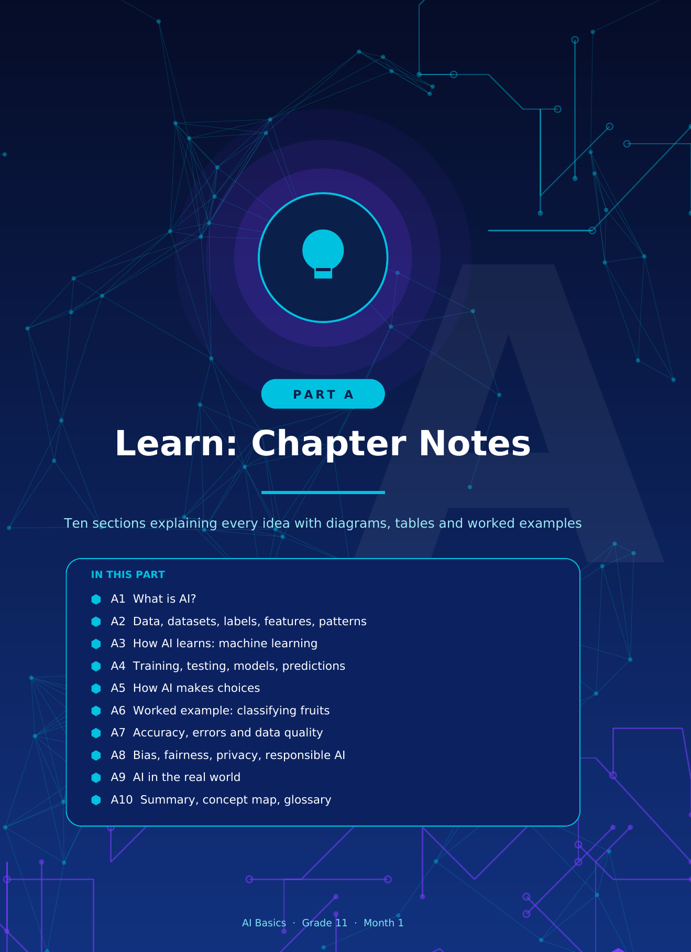

 | at  uctio | al I  ay ap | ce?
hink  cho  what | mor  pp s  o to | nlo  u ac  e us | you  wat  y u | pp ch  e de  telli | hose  evice  igen | stes  told  .

A1 What Is Artificial Intelligence?
Introduction to AI and its everyday applications
KEY DEFINITION
Artificial Intelligence (AI) is the ability of a computer system to perform tasks that normally need human intelligence, such as recognising pictures, understanding speech, making decisions and learning from experience.

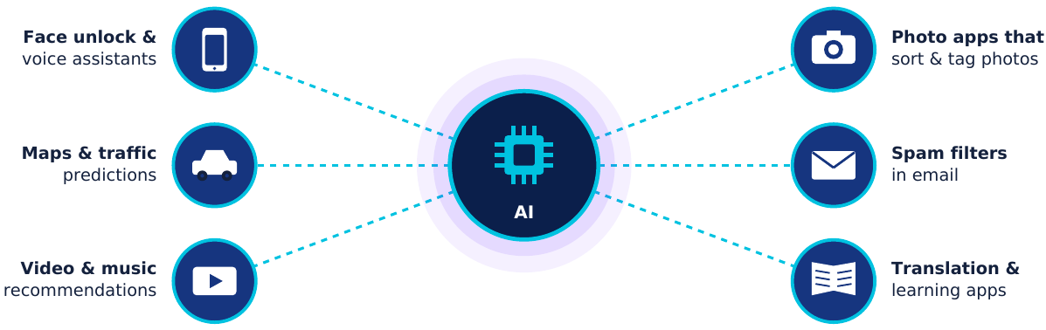
Figure 1.1 AI is already part of ordinary life.

What does "intelligent" mean for a machine?
- Perceive: notice the world through cameras, microphones and sensors (for example, seeing a face).
- Learn: improve from examples and experience instead of staying the same forever.
- Decide: choose an action, such as "unlock" or "keep locked".
- Predict: estimate what is likely to happen, such as traffic in 20 minutes.
- Communicate: use language, such as translating a sentence or answering a spoken question.

The simple flow inside every AI system
1
2
3
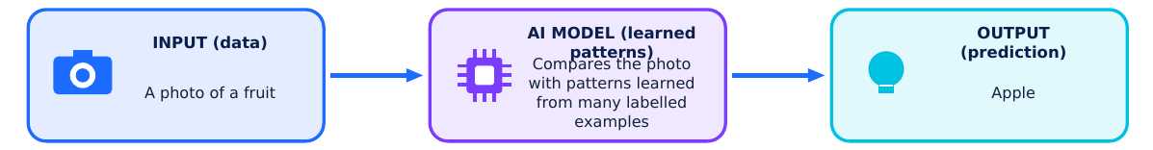
Every AI system follows this simple flow: Input → Process → Output
Figure 1.2 Input, process, output.
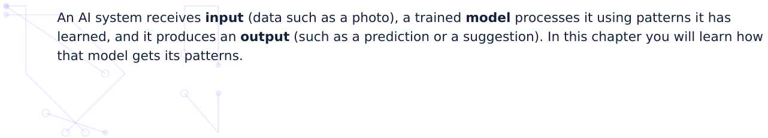

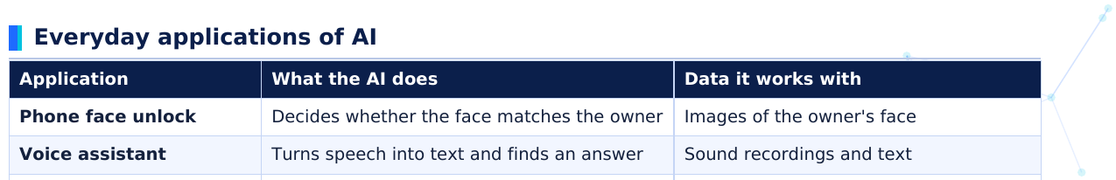
Application | What the AI does | Data it wo | orks with
Phone face unlock | Decides whether the face matches the owner | Images of th | he owner's face | e
Voice assistant | Turns speech into text and finds an answer | Sound reco | ordings and text | t
Maps and navigation | Predicts traffic and picks a quick route | Speeds from | m many phones | s, past traffic
Video / music apps | Suggests what you may enjoy next | What you w | watched, skippe | ed or liked
Email spam filter | Sorts mail into "spam" or "not spam" | Words, links | s and senders i | in emails
Typing suggestions | Predicts the next word you may type | Large amou | unts of written t | text
Photo gallery search | Finds photos of "beach" or "food" | Labelled pic | ctures

AI, Machine Learning and Deep Learning
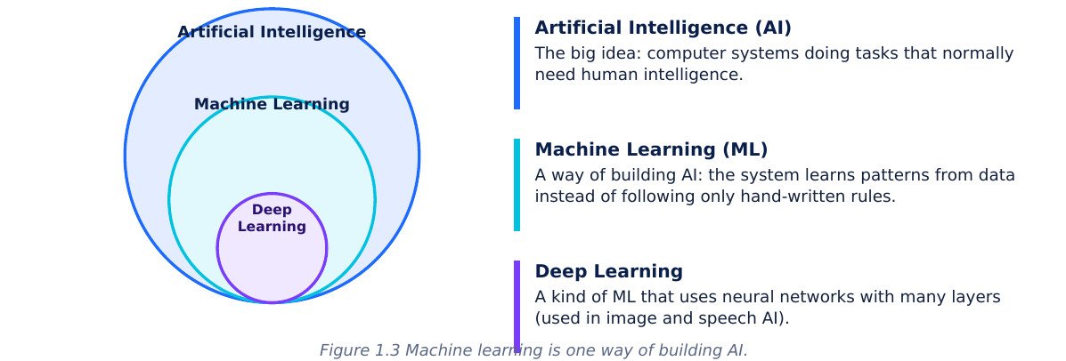

Humans and AI: different strengths
Aspect | Human intelligence | AI systems
Learning | Can learn a new idea from a few examples | Usually needs many examples to learn a pattern
Speed with big data | Slow to check thousands of items | Very fast at scanning huge amounts of data
Common sense and context | Strong: understands situations and feelings | Limited: works well only on what it was trained for
Tiredness | Gets tired and distracted | Does not get tired, but can still make mistakes
Responsibility | Can explain and take responsibility | Cannot be responsible: people must be

MYTH BUSTER
AI is not magic and it is not a human brain. It is mathematics, data and computing power, designed by people, and it can make mistakes. Understanding how it works helps us use it wisely.

Check Your Understanding
A1.1. Define AI in your own words and give one everyday example.

A1.2. Name three apps or devices you used this week that may use AI. For each, state what it does.

A1.3. A basic calculator adds 2 + 3 using fixed steps. Is it AI? Explain.

A2 Data, Datasets, Labels, Features and Patterns
The raw material that AI learns from
sounds that have been collected. The more carefully data is collected, the better an AI system can learn from it.
Numbers
Text
Images
Sound
Video
marks, heights,
messages, reviews,
photos, X-rays,
voice, music,
clips, camera
temperatures
book titles
leaf pictures
whale calls
footage
Figure 2.1 Common types of data.

Key words you must know
Term | Meaning | Fruit example
Data | Raw facts, numbers, text, images or sounds | The weight of a fruit, a photo of it
Dataset | A collection of related data organised for analysis, often a table | A table of 12 fruits with their measurements
Example (row, record, sample) | One item in the dataset | One particular banana
Feature | A characteristic of an example that can be measured or described. These are the inputs. | Colour, shape, diameter, surface
Label | The correct answer or category attached to an example. This is what we want the AI to predict. | Apple, Banana or Orange
Pattern | Something that repeats or follows a rule in the data | Every long fruit is a banana

FEATURES (inputs we measure)
LABEL
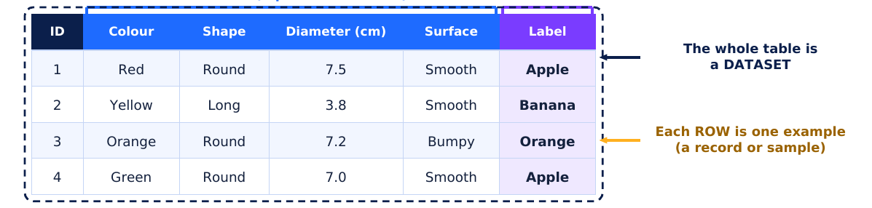
Colour
Shape Diameter (cm) Surface
Red
Round
7.5
Smooth
Yellow
Long
3.8
Smooth
Orange Round
7.2
Bumpy
Green
Round
7.0
Smooth

Pattern spotted: every "Long" fruit is a Banana; every "Round + Bumpy" fruit is an Orange.
Figure 2.2 Anatomy of a dataset.
REMEMBER
Features = what we know about the item (inputs). Label = what we want to find out
(output). If we are predicting a house price, the price is the label and area, rooms and location are
features.
(output). If we are predicting a house price, the price is the label and area, rooms and location are
features.

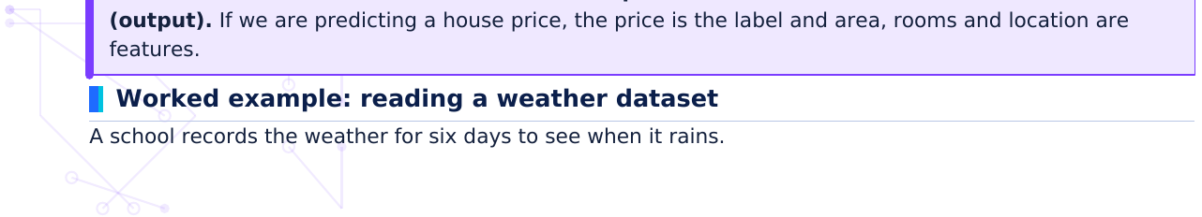

Day | Cloud cover | Humidity | Label: Rain?
1 | Heavy | High | Rain
2 | Clear | Low | No rain
3 | Heavy | High | Rain
4 | Light | Low | No rain
5 | Heavy | Low | No rain
6 | Light | High | No rain

- Step 1, find the features: cloud cover and humidity (day number is just an ID).
- Step 2, find the label: "Rain?" (Rain / No rain).
- Step 3, look for a pattern: it rained only on days with both heavy clouds and high humidity (days 1 and 3). Heavy clouds alone (day 5) or high humidity alone (day 6) did not bring rain.
- Step 4, use the pattern: a new day with heavy clouds and high humidity → predict Rain.

What makes data good?
Quality | Ask yourself | If it is missing...
Accurate | Are the values correct? | The AI learns wrong facts
Enough | Are there enough examples? | The AI cannot find reliable patterns
Varied (representative) | Does it cover all the kinds of cases we care about? | The AI fails on cases it never saw
Correctly labelled | Is every label right? | The AI is "taught" wrong answers
Relevant | Do the features help answer the question? | Useless features confuse the model

PATTERNS HAVE EXCEPTIONS
A pattern is a strong clue, not a guarantee. Most birds fly, but penguins do not. AI works with likelihoods, so it can still be wrong.

Check Your Understanding
A2.1. A house dataset has the columns: Area (sq m), Rooms, Location, Price. If we want AI to predict the
price, which are the features and which is the label?

A2.2. State one difference between a feature and a label.

A2.3. Give one real-life example of a pattern.

A3 | arn | nin
did  you  lar | a lis  he | t of  patte | es. Y  Ma | es,  ks i | , pe  in a | eople  a

A3 How AI Learns: Machine Learning
Learning from examples instead of fixed rules
KEY DEFINITION
Machine learning (ML) is a way of building AI in which a computer learns patterns from data and improves with experience, rather than being given every rule by a programmer.

Learning like a child, learning like a machine
A child learning "dog" | A machine learning to recognise dogs
Sees many different dogs | Is given many example photos (training data)
Adults say "this is a dog" or "that is a cat" | Each photo has a label
Guesses "cat" for a fox and is corrected | Compares its guess with the label and adjusts when wrong
Recognises a new dog never seen before | Makes a prediction on new data

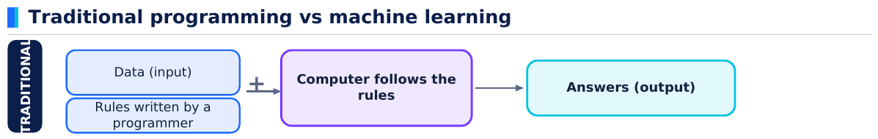
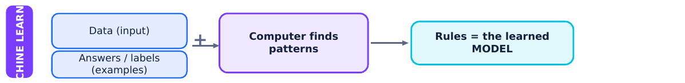
In ML, the computer works out the rules for itself by studying examples.
Figure 3.1 In ML the computer discovers the rules from examples.
 | Traditional programming | Machine learning
Who writes the rules? | The programmer | The computer finds them from data
Best for | Clear, fixed steps (e.g., add two numbers) | Tasks too complex for hand-written rules (e.g., recognising faces)
Needs lots of data? | No | Yes: examples are the teacher
Can improve with more data? | Only if the programmer rewrites it | Yes, by training again with better data

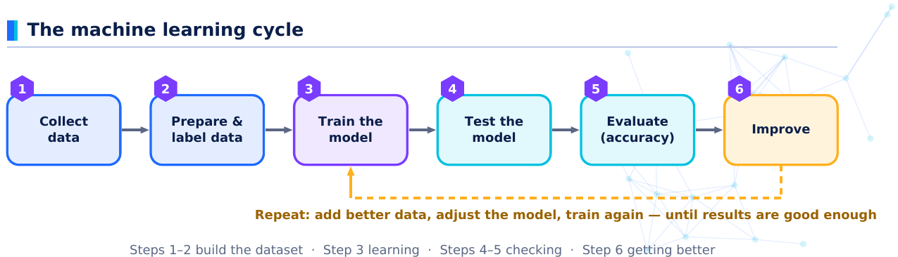
Figure 3.2 The six steps of the machine learning cycle.
- 1 Collect data: gather examples that represent the real problem (e.g., photos of fruit).
- 2 Prepare and label: clean mistakes, remove duplicates and attach the correct label to each example.
- 3 Train: the computer studies the training examples and finds patterns that link features to labels. The result is a model.
- 4 Test: give the model new examples it has not seen and record its predictions.
- 5 Evaluate: compare predictions with the real labels and calculate accuracy.
- 6 Improve: add better or more data, change features or settings, and train again.

Enrichment: a peek inside one kind of model
Many modern models are neural networks, drawn below in a simplified way. Information enters on the left, passes through connected layers where patterns are detected, and a prediction comes out on the right. During training the strengths of the connections are adjusted so predictions get closer to the labels.
INPUT LAYER
HIDDEN LAYER
OUTPUT LAYER
(features)
(finds patterns)
(prediction)
Diameter
Orange
Surface
Banana
Shape
Apple
A very simplified picture: connections carry numbers; training adjusts those numbers.
Figure 3.3 A simplified neural network (enrichment only).

Check Your Understanding
A3.1. In your own words, what does it mean when we say a machine "learns"?

A3.2. State two differences between traditional programming and machine learning.

A3.3. Put these steps in the correct order: Test, Collect data, Improve, Train.

an | dic
mu | eck | hy
 | ssif
 | with | s an
 | uits | s ne
or | h as | ana"
 | is a
 | how | 5 w
 | out us | unse the

used to CHECK the model
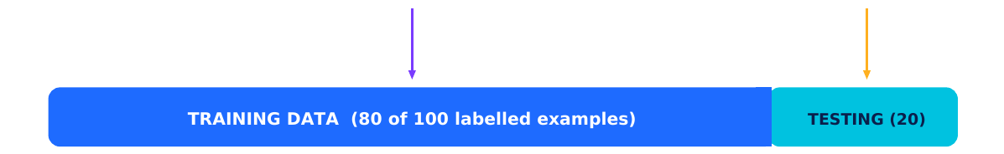
Golden rule: never judge a model only on the examples it has already studied.
Figure 4.1 A common way to split a dataset (80% training, 20% testing).
WHY KEEP TESTING DATA SEPARATE?
Imagine a teacher gives you the exact exam paper to practise from and then uses the same paper for your exam. A high mark would only show you memorised it, not that you understood. The same happens with AI: a model tested on the examples it studied can look perfect and still fail on new cases.

From training to prediction
- Training: the model is shown training examples with their labels and finds the patterns.
- Prediction: for a new example, the model looks at its features, matches them with learned patterns and outputs the most likely label.
- Evaluation: predictions on the testing data are compared with the true labels to measure performance.

Calculating accuracy
FORMULA
Accuracy (%) = (number of correct predictions ÷ total number of predictions) × 100
Error rate (%) = 100 − accuracy

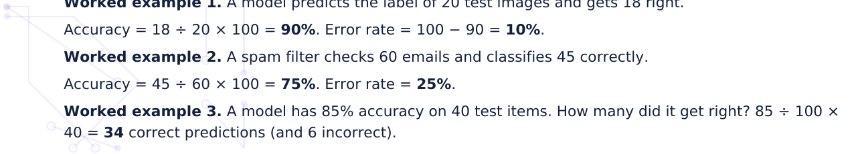

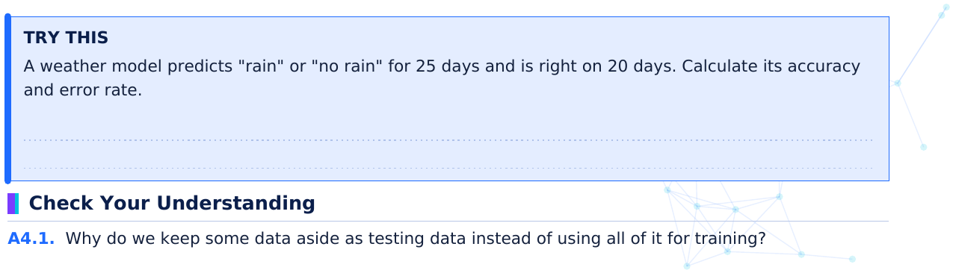
TRY THIS
A weather model predicts "rain" or "no rain" for 25 days and is right on 20 days. Calculate its accuracy and error rate.

A4.2. A model is correct on 36 of 40 test examples. Calculate the accuracy and the error rate.

A4.3. A teacher gives a model 200 labelled photos to learn from and 50 more to check it afterwards. Which
photos are the training data and which are the testing data?

M  reco | ke  end
mee  ern  as | new  lea  % s | n. It  est. | t co  . Ma | ompa  any s | the  tem | e fe  ms a | eat  also | ture  o re | es  epo
N |  |  |  | N | BER | R P | PRE | EDIC | CTIO

A5 How AI Makes Choices
Classification, recommendations, predictions and errors
Put an item into a group
Suggest what you may like
Estimate a number
Spam or not spam?
Songs, videos, books
Tomorrow's temperature,
Cat or dog photo?
and products
bus arrival time
Figure 5.1 Three common jobs for AI.
Task | Question it answers | Example input  E | Example output
Classification | Which group does this belong to? | An email  " | "Spam" or "Not spam"
Recommendation | What might this person like? | A viewing history  A | A list of suggested videos
Number prediction | What number is likely? | Today's temperature  E | Expected ice-cream sales: 78

1 Classification: choosing a category
Suppose a simple spam filter has learned these clues. Each clue adds or removes "spam points", and an email with 3 or more points is called spam. (Real filters learn such weights automatically from thousands of emails.)
Clue in the email | Points
Contains "WIN FREE PRIZE" | +2
Sender is unknown | +1
Has many links | +1
Sender is in your saved contacts | −2

Email A: "WIN FREE PRIZE", unknown sender, many links → 2 + 1 + 1 = 4 points → Spam.
Email B: homework reminder from a saved contact, no links → −2 points → Not spam.

2 Recommendation: suggesting what fits
Recommendation systems look at what you did before and at what similar people liked. Meena's watch history this week is shown below.
Type of video | Videos watched | Share of history
Science | 5 | 5 ÷ 8 = 62.5%
Cooking | 2 | 2 ÷ 8 = 25%
Comedy | 1 | 1 ÷ 8 = 12.5%

Since science dominates her history, the system will most likely suggest more science videos first. If Meena starts watching more cooking, the suggestions will gradually change.

3 Number prediction: estimating a quantity
A shop records ice-cream sales at different temperatures.

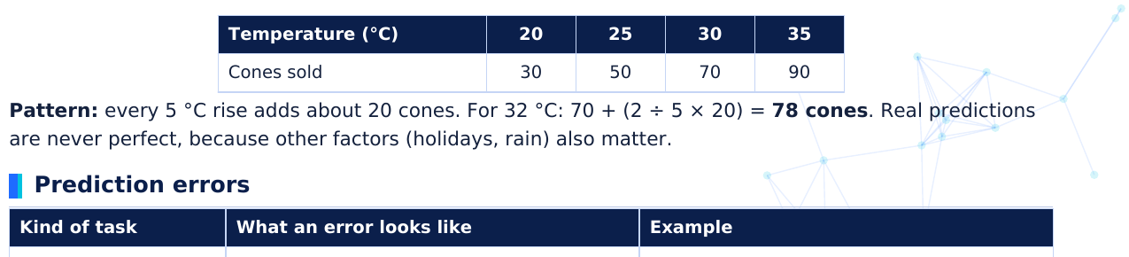
Temperature (°C) | 20 | 25 | 30 | 35
Cones sold | 30 | 50 | 70 | 90

Kind of task | What an error looks like | Example
Classification | Wrong category | A real email is alarm), or a s miss) | marke am e | ed spam (a email gets th | a false hrough (a
Number prediction | A gap between the predicted and actual numbers: error = actual − predicted | Predicted 78 c cones | nes, | actual 85 → | → error = 7
Recommendation | Suggestion you do not like | A song you sk | imm | mediately

NOT ALL ERRORS COST THE SAME
A false alarm from a spam filter is a small nuisance. A miss from a medical screening tool could delay treatment. When choosing and checking AI systems we must ask: which mistakes matter most?

Check Your Understanding
A5.1. Name the task (classification, recommendation or number prediction): (a) sorting mail into folders;
(b) suggesting a song; (c) estimating tomorrow's rainfall in mm.

A5.2. Using the spam-points rules, calculate the points for an email with "WIN FREE PRIZE", many links,
and a saved-contact sender. Is it spam?

A5.3. A model predicted 78 cones but 90 were sold. What is the error?

build  Note | d a m  e: rea | el t  yste | tha  em
 |  | Lab | bel
 |  | App | ple
 |  | App | ple
 |  | App | ple
 |  | App | ple
 |  | ana | ana
 |  | ana | ana
 |  | ana | ana
 |  | ana | ana
 |  | ran | nge
 |  | ran | nge
 |  | ran | nge
 |  | ran | nge

A6 Worked Example: AI Classifying Fruits
A complete mini machine learning project, step by step

Step 3: Study the features and look for patterns
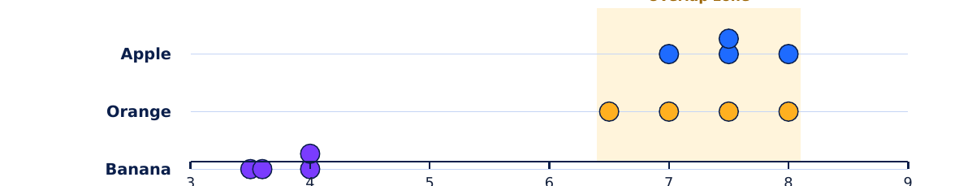
Diameter (cm)
Figure 6.1 Diameters of the training fruits. Bananas are clearly thinner, but apples and oranges overlap.
Feature | Pattern in the training data | How useful?
Shape | All 4 bananas are Long; all apples and oranges are Round | ★★★ Separates bananas perfectly
Surface | All 4 oranges are Bumpy; all apples and bananas are Smooth | ★★★ Separates oranges perfectly
Diameter | Bananas 3.5 to 4.0 cm; apples and oranges 6.5 to 8.0 cm | ★★ Finds bananas, cannot split apples/oranges
Colour | Apples red or green; bananas yellow or green; oranges orange | ★ Helpful but unreliable (green appears on two fruits)

Step 4: Train, which gives us the model
From the patterns the model learns three simple rules (shown as a decision flowchart):

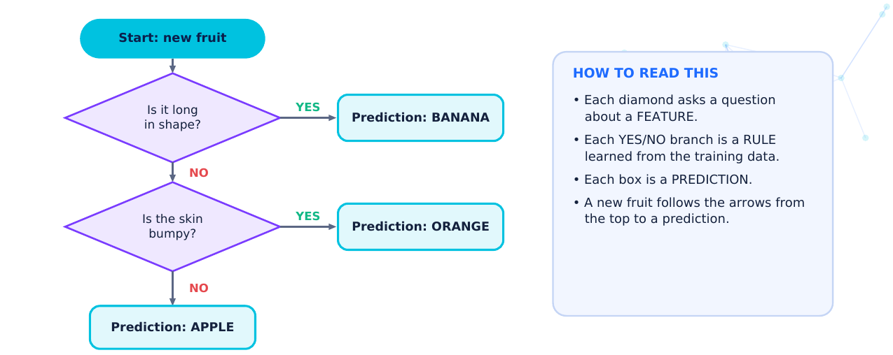
Figure 6.2 The learned model as a decision flowchart.

Step 5 and 6: Test on 5 new fruits and evaluate
These fruits were not in the training data.
ID | Colour | Shape | Diameter | Surface | Model predicts | Actual fruit | Result
T1 | Red | Round | 7.8 | Smooth | Apple | Apple | ✓ Correct
T2 | Yellow | Long | 3.9 | Smooth | Banana | Banana | ✓ Correct
T3 | Orange | Round | 7.2 | Bumpy | Orange | Orange | ✓ Correct
T4 | Green | Round | 7.0 | Smooth | Apple | Apple | ✓ Correct
T5 | Orange | Round | 7.0 | Smooth | Apple | Orange | ✗ Wrong

EVALUATION
Correct predictions = 4 out of 5. Accuracy = 4 ÷ 5 × 100 = 80%. Error rate = 20%.

Step 7: Why did the model get T5 wrong?
T5 is a real orange with a smooth skin (some orange varieties are smooth). In the training data, every orange was bumpy, so the model learned "smooth and round means apple". The mistake did not come from a faulty computer. It came from missing examples in the training data.

Step 8: Improve and retest
- Add more training examples, including smooth-skinned oranges, red and green apples of different sizes, and bananas at different ripeness.
- Add a helpful feature, for example a more precise colour measurement.
- Train again, test on fresh fruits and recalculate accuracy.
LIMITATION TO REMEMBER
This model knows only three fruits. Show it a mango and it will still answer Apple, Banana or Orange, because those are the only answers it knows. AI is only as broad as its training data.

Check Your Understanding
A6.1. Which single feature separated the bananas from the other fruits perfectly?

A6.2. Use the model to predict: Green, Round, 7.2 cm, Bumpy. Show your reasoning.

A6.3. Suggest one way to improve the fruit model, and explain why it would help.

ct  to r | Da | ua | ity
Goo  ct | ers a | w ac | cur | s it
ct
s | Exa
amp | Only | s of | ach | dis
r ca | 95 p | dayt | me, | nigh
valu | A ca | abel | ed "d
not c | Pred stud | xam m | mark | hout
diffe | A m fog | ned o | n su | hot
may | A blu | tly h | dden | ct

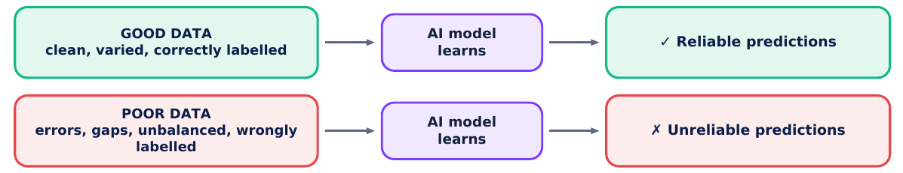
"Garbage in, garbage out": a model can only be as good as the data it learns from.
Figure 7.1 Garbage in, garbage out.
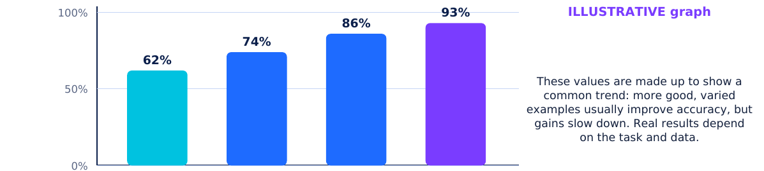
10
50
200
1000
Number of good training examples
Figure 7.2 More good-quality data usually helps (illustrative values).

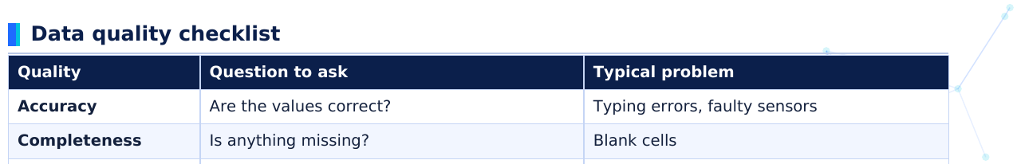
Quality | Question to ask | Typical proble | em
Accuracy | Are the values correct? | Typing errors, f | faulty sensors
Completeness | Is anything missing? | Blank cells
Consistency | Is it recorded in the same way? | cm in one row, | mm in another | r
Variety | Does it cover all cases? | Only one type o | of image
Correct labels | Is each label right? | Mistakes by tire | ed labellers
No duplicates | Is any row repeated? | Same example | counted twice

Worked example: cleaning a messy dataset
Spot the problems in this raw fruit table before using it for training.
Row | Colour | Shape | Diameter (cm) | Label | Problem?
1 | Red | Round | 7.5 | Apple | None
2 | Yellow | Long | 3.8 | Banana | None
3 | Orange | Round | 70 | Orange | Impossible value (probably 7.0)
4 | Green | Round | (blank) | Apple | Missing value
5 | Yellow | Long | 3.8 | Apple | Wrong label (long yellow fruit)
6 | Yellow | Long | 3.8 | Banana | Duplicate of row 2

ACCURACY IS NOT THE WHOLE STORY
A hospital tests a model on 100 patients. Only 5 have a disease. A lazy model that says "healthy" for everyone is right for 95 patients: 95% accuracy, yet it finds 0 of the 5 patients who need help. Always ask which cases the model gets wrong, not only how many.

Check Your Understanding
A7.1. List three reasons why an AI model might make incorrect predictions.

A7.2. A model gets 40 of 50 test items right. What is its accuracy?

A7.3. Explain "garbage in, garbage out" with an example.

AI
AI
ws is | s sh | how | . So

A8 Bias, Fairness, Privacy and Responsible AI
Using AI in ways that are fair, safe and respectful
KEY DEFINITION
Bias in AI means results that are systematically unfair to some people or groups. It usually comes from the data a model learned from or from the way the system was designed, not from the computer having opinions.

Where does bias come from?
Source | Explanation | Example
Unbalanced data | Some groups are rare in the training data | A face-unlock model trained mostly on one group of faces
Historical bias | Data records past unfair decisions, and the model copies them | A hiring model learning from years of biased hiring
Labelling bias | People who label data bring their own assumptions | Photos labelled with stereotypes
Design choices | Choosing features that stand in for sensitive details | Using home address as a clue that unfairly affects some areas

Training examples per group (of 100)
Illustrative accuracy per group
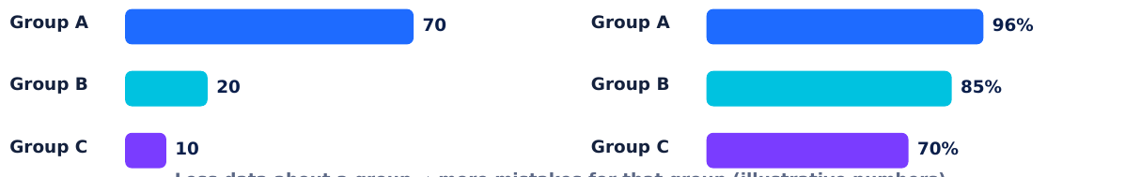
Figure 8.1 Unbalanced training data can lead to uneven accuracy (illustrative numbers).
REAL-WORLD EXAMPLES
Face analysis (2018): researchers reported that some commercial face-analysis programs made many more errors for darker-skinned women than for lighter-skinned men; unbalanced training data was one reason.
Hiring tool (2018): news reports described a company that stopped using an experimental recruiting tool after finding that, having learned from past hiring data, it favoured male applicants.

Fairness
Fairness means an AI system treats people and groups equitably and does not harm some groups more than others. Designers can ask: Who is in our data and who is missing? Is accuracy similar for different groups? Could a mistake hurt someone badly? A model with high overall accuracy can still be unfair if its mistakes are concentrated on one group.
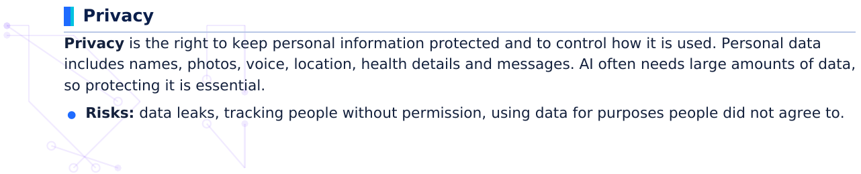

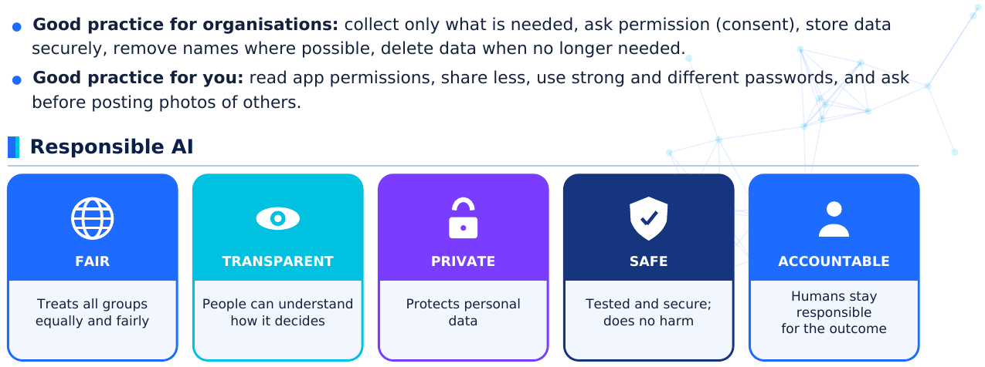
Figure 8.2 Five pillars of responsible AI.
KEEP HUMANS IN THE LOOP
For important decisions (health, exams, jobs, safety) AI should assist people, not decide alone. A human must be able to review, question and correct the AI's output, and a person or organisation must stay accountable.

Situation | Concern | Responsible action
A school plans AI cameras to record attendance | Privacy of students' faces; mistakes marking absent | Ask consent, store securely, allow manual correction
A loan app trained mostly on city customers | Poor accuracy for villages | Collect data from all areas and test each group
A health app suggests a diagnosis | A wrong suggestion could harm | Doctor reviews; app explains it is only advice

Check Your Understanding
A8.1. What is bias in AI? Give one example of how it can arise.

A8.2. Name two ways you can protect your privacy when using AI apps.

A8.3. Why should a human review important AI decisions, such as medical advice?

9 | ea  kes a
9 | ea
9
9 | kes a
me  xam | ed (  om | s, a | urac | any
E
E

A9 AI in the Real World
Six fields where AI makes a difference
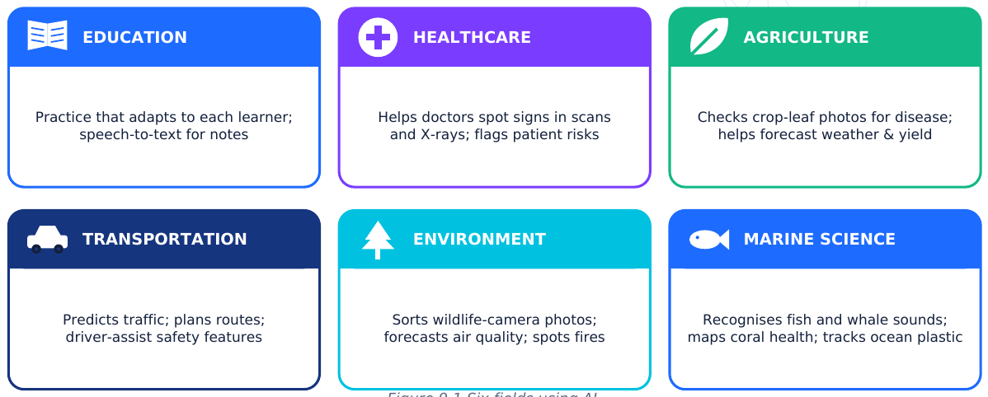
Field | Data used | What the AI does | Human role / limitation
Education | Answers to practice questions, reading time, speech | Chooses the next practice task; converts speech to text | Teachers guide learning; student data must be protected
Healthcare | Labelled X-rays, scans, patient records | Highlights areas that may need a closer look; estimates risk | Doctors make the final decision; bias in data is a danger
Agriculture | Leaf photos, soil, weather, satellite images | Spots crop disease; helps plan irrigation and forecast yield | Needs local examples; conditions vary by place and season
Transportation | Speeds of many vehicles, maps, sensors | Predicts traffic and arrival times; supports driver-assist safety | Safety-critical: rigorous testing and human oversight
Environmental protection | Wildlife camera photos, sound sensors, satellite images | Identifies animals; detects possible fires or illegal logging; forecasts air quality | Needs checking by scientists; false alarms waste effort
Marine science | Underwater video, hydrophone sounds, satellite and drone images | Recognises fish and whale calls; maps coral health; finds floating plastic | Murky images and little labelled data make it hard

Education. Adaptive learning programs study which questions a student answers correctly and then choose the next question at the right difficulty. Speech-to-text tools help students who find writing hard. Teachers can also spot topics a whole class finds difficult. Caution: student data is personal and must be kept private.
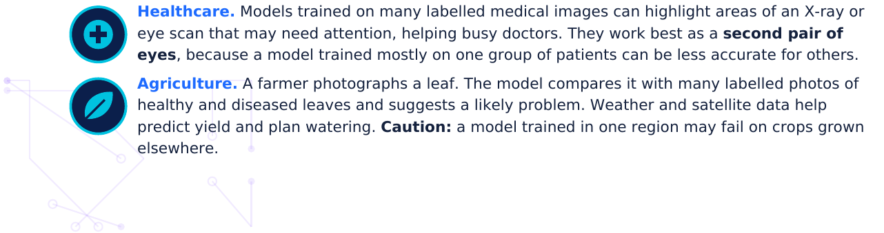

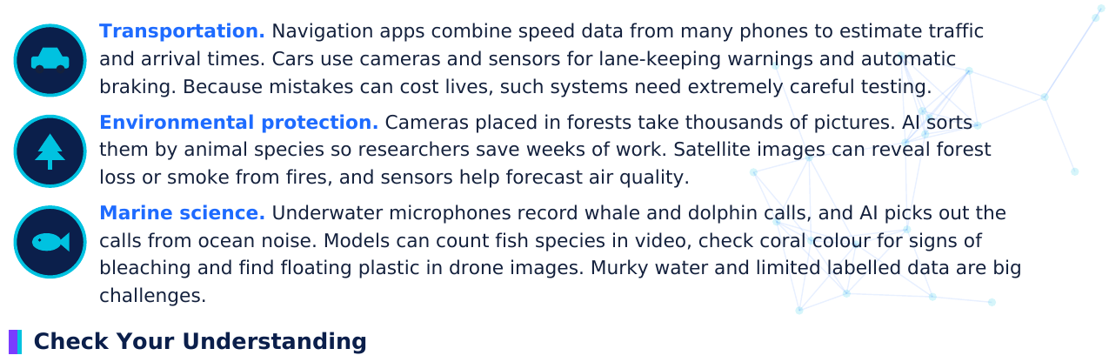
A9.1. Choose one field from this section. Describe the data used, the pattern the AI looks for and the
output it gives.

A9.2. Why is an AI tool for X-rays described as a "second pair of eyes" rather than a replacement for a
doctor?

A9.3. Why should a crop-disease model be tested on leaves from local farms before being trusted?

mm | sa
r

A10 Chapter Summary, Concept Map and Glossary
Bringing it all together
1. AI lets computers do tasks that normally need human intelligence.
2. AI learns from data: datasets made of examples with features (inputs) and labels (answers).
3. Machine learning finds patterns in data instead of following only hand-written rules.
4. The ML cycle: collect data → prepare → train → test → evaluate → improve.
5. Training data teaches the model; testing data checks it on new cases.
6. A model uses learned patterns to make predictions: classification, recommendation or numbers.
7. Accuracy = correct ÷ total × 100, but ask which mistakes the model makes.
8. Poor, little or unbalanced data causes errors: garbage in, garbage out.
9. Bias and privacy problems are real risks; responsible AI is fair, transparent, private, safe and
accountable.
10. AI helps in education, healthcare, agriculture, transport, the environment and marine science, with
humans in the loop.
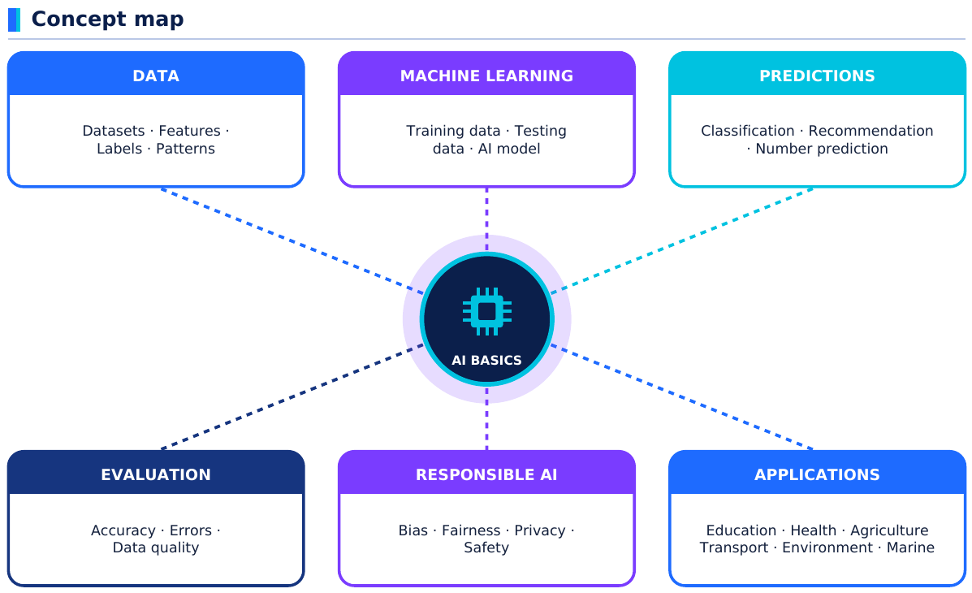
Figure 10.1 Concept map of Chapter 1.

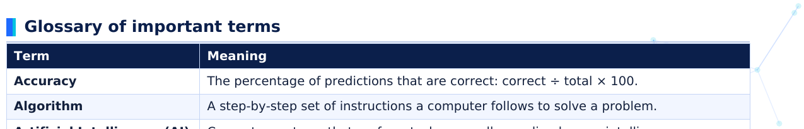
Term | Meaning
Accuracy | The percentage of predictions that are correct: correct ÷ | total × 100.
Algorithm | A step-by-step set of instructions a computer follows to so | olve a problem. | .
Artificial Intelligence (AI) | Computer systems that perform tasks normally needing h | human intelligen | nce.
Bias | Systematic unfairness in AI results, often caused by unba | alanced or unfai | ir data.
Classification | Placing an item into one of several groups, such as spam | or not spam.
Data | Facts, numbers, text, images or sounds that have been co | ollected.
Data quality | How accurate, complete, consistent and relevant data is.
Dataset | An organised collection of related data, often a table of ex | xamples.
Deep learning | Machine learning that uses neural networks with many lay | yers.
Error (prediction error) | A prediction that does not match the true answer.
Evaluation | Measuring how well a model performs, usually on testing | data.
Fairness | Treating people and groups equitably in AI decisions.
Feature | A measurable characteristic of an example; an input to th | he model.
Human in the loop | A person who reviews or controls important AI decisions.
Label | The correct answer or category attached to an example.
Machine learning | A way of building AI that learns patterns from data.
Model | The result of training: patterns or rules used to make pred | dictions.
Neural network | A model made of connected layers of simple units, loosely | y inspired by th | he brain.
Pattern | A regularity or repeated relationship in data.
Prediction | The output a model gives for new input data.
Privacy | The right to keep personal information protected and und | der your control | l.
Recommendation | A suggestion of items a person may like, based on pattern | ns.
Responsible AI | AI that is fair, transparent, private, safe and accountable. | .
Testing data | Labelled examples kept aside to check a trained model on | n new cases.
Training data | Labelled examples the model learns from.

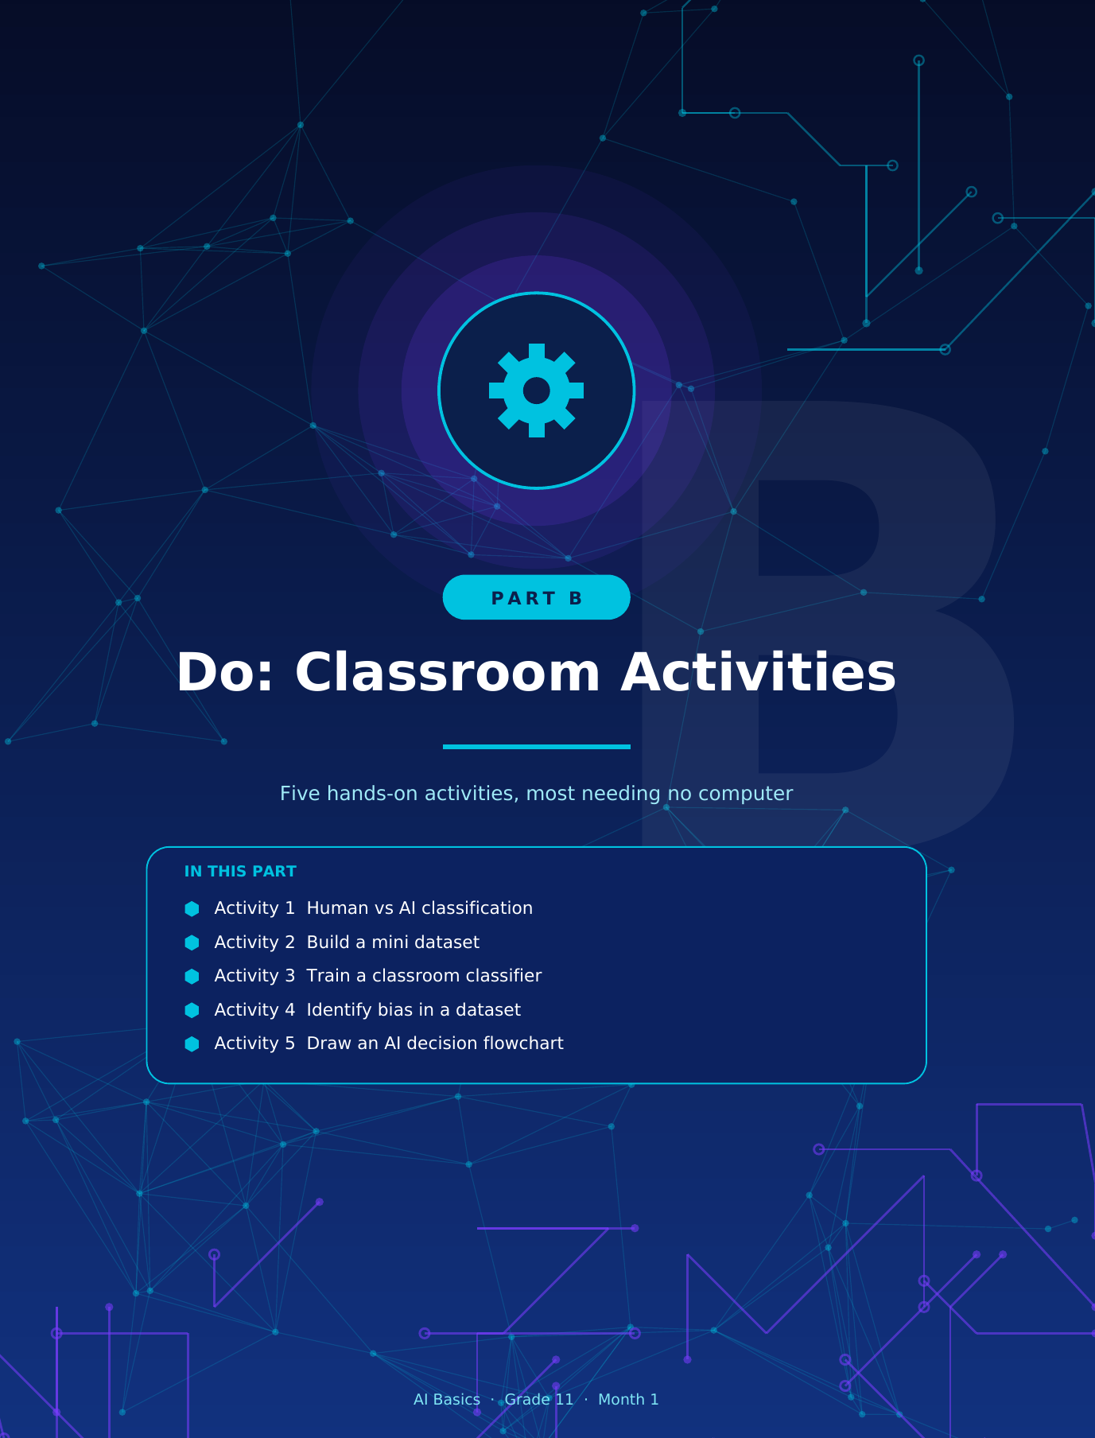

tio
chno ivity | pute

B1 Activity 1: Human vs AI Classification
Can a rule-following "AI" sort animals as well as a human?
Learning objectives
Materials
- Compare how a human and a rule-based "AI"
- 10 animal cards (cut from the table below,
classify.
name on the front, feature slip on the back)
- Identify features and rules used for classification. One Rule Card
- Calculate accuracy and find out why mistakes
- Paper, pencils, a timer
happen.

Card table (copy each row onto a card)
Card | Legs | Has wings? | Body covering | True group (teacher only)
Dog | 4 | No | Fur | Mammal
Cat | 4 | No | Fur | Mammal
Cow | 4 | No | Fur | Mammal
Sparrow | 2 | Yes | Feathers | Bird
Parrot | 2 | Yes | Feathers | Bird
Eagle | 2 | Yes | Feathers | Bird
Goldfish | 0 | No | Scales | Fish
Salmon | 0 | No | Scales | Fish
Penguin | 2 | Yes | Feathers | Bird
Bat | 2 | Yes | Fur | Mammal

THE RULE CARD (given only to the "AI" student)
Rule 1: If it has wings → write Bird. Rule 2: Otherwise, if it has fur → write Mammal. Rule 3: Otherwise, if it has scales → write Fish.

Step-by-step instructions
Step 1. One student is the "AI". The "AI" may only look at the feature slip (legs, wings, covering) and the
Rule Card. The animal name is hidden and no outside knowledge is allowed.
Step 2. Another student is the "Human". The Human sees the full card including the name and can use
anything they know.
Step 3. A third student reads each card aloud. Human and "AI" each write a group (Mammal, Bird or Fish)
in the table without discussing.
Step 4. The group checks the answers against the "True group" column. Tick or cross each answer.
Step 5. Calculate each player's accuracy and discuss any card the "AI" got wrong.

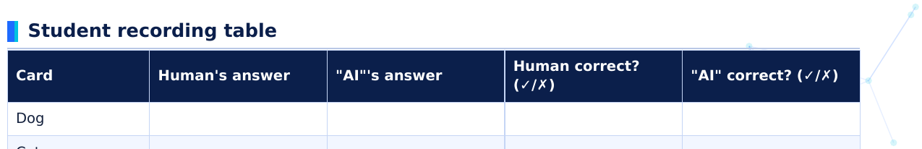
Card | Human's answer | "AI"'s answer | Human correct? (✓/✗) |  | "AI" cor | rrect? (✓/✗)
Dog
Cat
Cow
Sparrow
Parrot
Eagle
Goldfish
Salmon
Penguin
Bat

Human accuracy = ____ ÷ 10 × 100 = ______ % "AI" accuracy = ____ ÷ 10 × 100 = ______ %

Student tasks
1. Which card(s) did the "AI" classify wrongly? Explain why the rules failed.

2. Rewrite the Rule Card so that the "AI" would get all ten cards right. Does your new rule always work?
Think of an animal that might break it.

Expected outcomes
- The human sorts all 10 cards correctly using background knowledge.
- The rule-following "AI" gets 9 of 10 right (accuracy 90%) and misclassifies the bat as a bird because it has wings.
- Students see that AI follows features and rules it is given and can fail on unusual cases.

Discussion questions
1. Why did the human succeed where the "AI" failed?
2. Is a 90% accurate classifier good enough for sorting animal cards? For identifying medicines? Why might
the answer differ?
3. How could an AI be given more information (features) to avoid the mistake?
TEACHER GUIDANCE
Make sure the "AI" student does not use outside knowledge. Hide the name side from them.
Many groups fix the bat by putting the "fur" rule first, which works here but may fail later. Use this to
show that rules built from few examples are fragile.
Extension: invent a new card (for example a platypus: fur, lays eggs, has a bill) and test the rules.
show that rules built from few examples are fragile.
Extension: invent a new card (for example a platypus: fur, lays eggs, has a bill) and test the rules.

B2 Activity 2: Build a Mini Dataset
Collect, record and check your own data
Learning objectives
Materials
- Create a small dataset with features and a label. 10 small objects from the classroom (pen,
pencil, eraser, ruler, sharpener, marker,
- Check the dataset for data-quality problems.
notebook, scissors, glue stick, compass)
- Look for patterns in the data you collected.
- Ruler, paper, pencil
PRIVACY RULE
Collect data about objects, not about classmates' personal details (no photos, ages, addresses or marks).

Step-by-step instructions
Step 1. Choose a question to answer. Our question: "Is this item a writing tool?" (Yes / No). This will be
your label.
Step 2. Choose at least three features to measure or describe. Suggested: length (cm), main colour,
main material.
Step 3. Place ten objects on the desk. Measure and record every feature using the same unit
(centimetres) for every item.
Step 4. Add the label for each item.
Step 5. Swap datasets with another group. They check for missing, unclear or inconsistent entries and
report back.
Step 6. Study the data and write down two patterns you notice.

Student data table
ID | Item | Length (cm) | Main colour | Main material | Label: Writing tool?
0 | Pencil (example) | 17.5 | Yellow | Wood | Yes
1
2
3
4
5
6
7
8
9
10

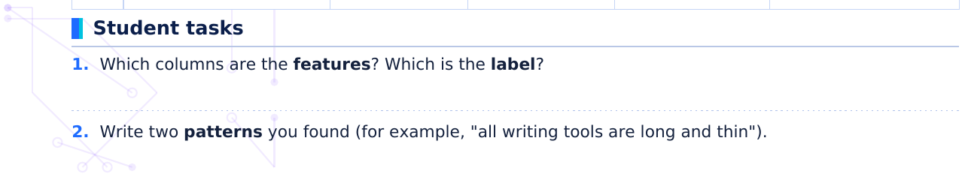

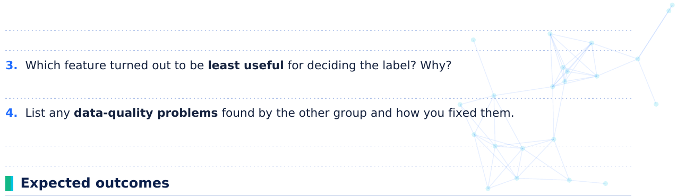
- A table of 10 or more rows, at least 3 features and one clear label, all measured in consistent units.
- Patterns such as "writing tools are long and thin" or "erasers and sharpeners are short". Colour usually turns out to be a weak clue.
- Students experience how easily errors, missing values or inconsistent units appear.

Discussion questions
1. Would your dataset be enough to train a real AI? Why or why not?
2. What kinds of objects are missing from your dataset?
3. How would a mistake in one row affect a model?
TEACHER GUIDANCE
Alternative themes: leaves, snacks, shoes, or shapes. Keep to objects, not personal data about students.
Emphasise consistent units (all cm) and decide in advance what to do when information is missing.
Collect the datasets: some can be reused in Activity 5 as input for flowcharts.

om  the | ass
tea | ech olou | Non er | rds | de fr | rom | m

B3 Activity 3: Train a Classroom Classifier
The class becomes the "model": learn from examples, then predict
Learning objectives
Materials
- Experience training, testing and evaluating a model. Paper cut-outs in several colours, shapes and
sizes (or use the tables below)
- Discover that some features matter and others do
not.
- A sealed envelope with the teacher's secret rule
- See how more training data improves a model.
The teacher secretly decides how cards are sorted into Group SUN and Group MOON. Your team must learn the rule from examples.

Step-by-step instructions
Step 1. Training: study the 10 training cards below with their labels. Decide which feature(s) seem to
matter.
Step 2. Write your team's rule in the box.
Step 3. Prediction: without help, predict SUN or MOON for the 6 test cards.
Step 4. The teacher reveals the true labels. Count correct predictions and calculate accuracy.
Step 5. Improve: the teacher shows 4 more training cards. Update your rule and re-predict any wrong
test cards.

Training data
# | Colour | Shape | Size | Label
1 | Red | Circle | Large | Sun
2 | Blue | Square | Small | Moon
3 | Red | Triangle | Small | Sun
4 | Blue | Circle | Large | Moon
5 | Red | Square | Large | Sun
6 | Blue | Triangle | Small | Moon
7 | Red | Circle | Small | Sun
8 | Blue | Square | Large | Moon
9 | Red | Triangle | Large | Sun
10 | Blue | Circle | Small | Moon

Your model
Features that seem to matter: ______________________ Features that do not seem to matter: ______________________
Our rule: If ________________________________ then SUN, otherwise MOON.

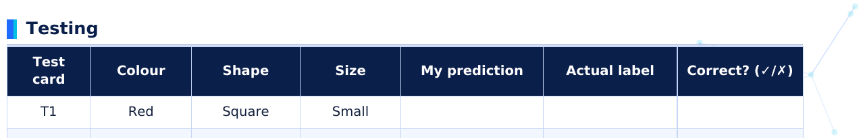
Test card | Colour | Shape | Size | My prediction | Actua | al label | Co | orrect? (✓/✗)
T1 | Red | Square | Small
T2 | Blue | Triangle | Large
T3 | Red | Circle | Medium
T4 | Blue | Square | Medium
T5 | Red | Triangle | Medium
T6 | Green | Circle | Medium

Accuracy = ____ ÷ 6 × 100 = ______ %

Improving the model
# | Colour | Shape | Size | Label
11 | Orange | Square | Large | Sun
12 | Green | Triangle | Small | Moon
13 | Yellow | Circle | Small | Sun
14 | Purple | Square | Medium | Moon

1. Why was it hard to predict test card T6 before the extra cards? What did the model lack?

2. After the extra cards, rewrite your rule. Did your accuracy improve?

Expected outcomes
- Teams notice that colour decides the group while shape and size are irrelevant.
- T1 to T5 are predicted correctly by a colour rule. T6 (green) is uncertain at first because green never appeared in training; typical accuracy is 5 of 6 (83%).
- After the extra cards (orange, green, yellow, purple), the rule "warm colours = SUN, cool colours = MOON" gives 6 of 6 (100%).

Discussion questions
1. Which features did your model ignore? Why is it important to ignore irrelevant features?
2. What happened when the model met a colour it had never seen?
3. How does this show the value of varied training data?
TEACHER GUIDANCE
Secret rule: SUN = warm colours (red, orange, yellow); MOON = cool colours (blue, green, purple). Seal
it before the lesson.
Do not let teams see the test labels until all predictions are written down. Link back to why testing data
must stay unseen.
must stay unseen.

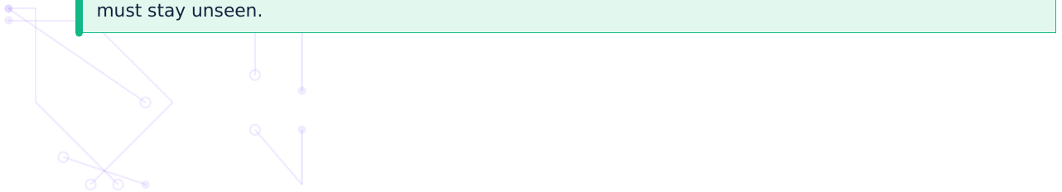

B4 Activity 4: Identify Bias in a Dataset
Who is in the data and who is missing?
Learning objectives
Materials
- Calculate how groups are represented in a dataset. The dataset summaries below
- Predict how an unbalanced dataset could lead to Calculator (optional)
unfair results.
- Chart paper and markers
- Propose fair ways to collect better data.
SCENARIO
A school district wants an AI tool to recommend students for a sports-talent programme. The tool learned from the records of 40 students chosen in past years. Your team is the review panel. Is this training data fair?

A sample of the training records
ID | Gender | School location | Main sport | Selected before?
1 | Boy | City | Football | Yes
2 | Boy | City | Football | Yes
3 | Girl | City | Running | No
4 | Boy | Village | Running | No
5 | Boy | City | Football | Yes
6 | Girl | Village | Kabaddi | No
7 | Boy | City | Football | Yes
8 | Boy | City | Running | Yes

Summary of all 40 records
Group | Number of students | Percentage of dataset
Boys | 36 | ____ %
Girls | 4 | ____ %
City schools | 34 | ____ %
Village schools | 6 | ____ %
Football | 30 | ____ %
Running | 6 | ____ %
Kabaddi | 4 | ____ %

Step-by-step instructions
Step 1. Calculate each percentage (number ÷ 40 × 100) and fill in the table.
Step 2. Circle the groups that are under-represented.
Step 3. In the sample records, look at who was "Selected before?". Describe the pattern. Is it fair to call it
talent, or could past choices have been unfair?
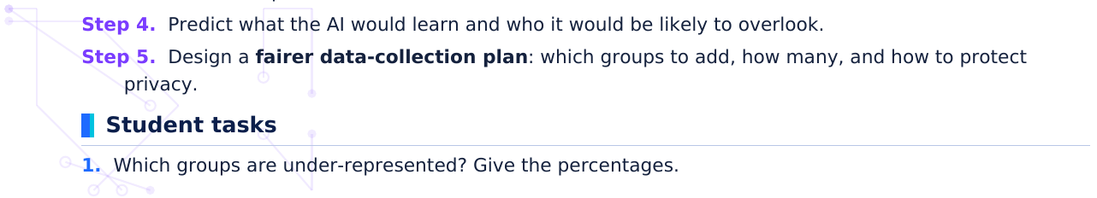

2. What pattern would the AI learn from the "Selected before?" column? Write it as a rule.

3. Describe two ways this AI could treat students unfairly.

4. Write a three-point plan to build a fairer dataset.

Expected outcomes
- Percentages: Boys 90%, Girls 10%; City 85%, Village 15%; Football 75%, Running 15%, Kabaddi 10%.
- The pattern: selected students were all city boys, mostly footballers. The AI would learn "city + boy + football = talented".
- A fairer plan: gather records from more girls and village schools, include more sports, test accuracy separately for each group, add human review and obtain consent.

Discussion questions
1. Is the problem the computer, or the data? Explain.
2. Is a model trained on this data "objective"? Why not?
3. Who should be involved in deciding what fair data looks like?
TEACHER GUIDANCE
Link to historical bias (past decisions copied by the model) and unbalanced data.
Use hypothetical records only. Do not collect or discuss real students' gender or location data.
Accept any reasonable fix. Look for: more diverse data, testing per group, human oversight, privacy.

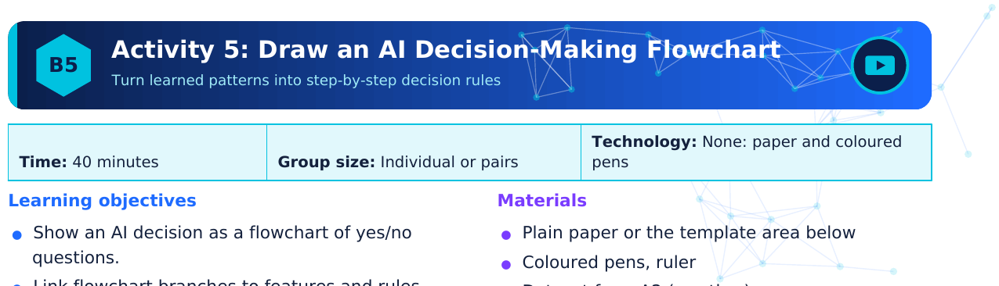
on- | Flo
on- | Flo
rs | ogy

- Dataset from A2 (weather) or your own
learned from data.
- Test a flowchart with new cases.

Flowchart symbols
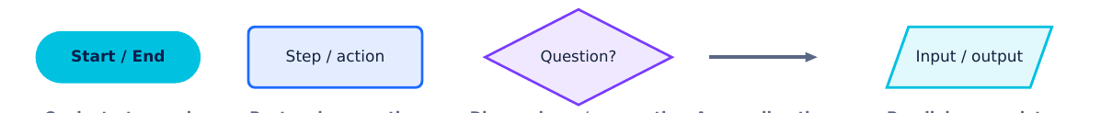
Oval: start or end Rectangle: an action Diamond: yes/no question Arrow: direction Parallelogram: data Remember: every diamond asks one yes/no question about a feature. Every path must end at an output (a prediction).

Step-by-step instructions
Step 1. Task A (guided): Use the weather dataset from section A2 (heavy clouds + high humidity =
rain). Draw a flowchart that predicts Rain or No rain.
Step 2. Task B (your own): Choose a decision such as "Which transport should I take to school?",
"Should I carry a raincoat?" or "Is this email spam?". List 2 or 3 features.
Step 3. Decide the order of questions and the outputs. Draw the flowchart with the correct symbols.
Step 4. Test it with the three scenarios in the table. Does every scenario reach an output?
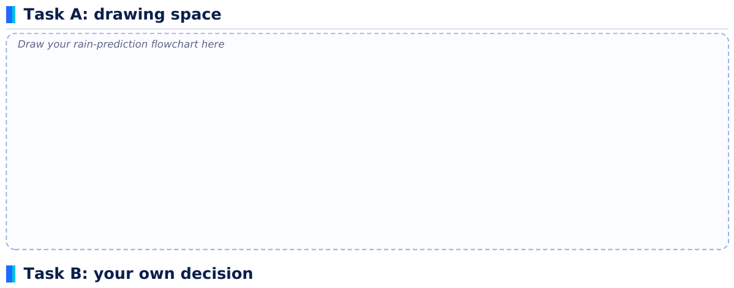
My decision: _______________________________________ Features used: _______________________________

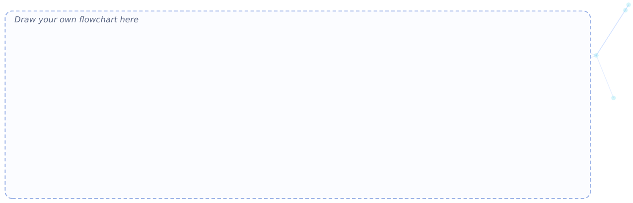
Test scenario | Features | Output from my flowchart | Sensible? (✓/✗)
1
2
3

Expected outcomes
- Task A flowchart: Start → "Heavy clouds?" → if yes → "High humidity?" → if yes: Rain; any "No" leads to No rain.
- Task B: a clear flowchart with start/end ovals, at least two diamonds, labelled yes/no arrows and an output on every path.
- Students recognise that a decision flowchart is a simple picture of what a model has learned.

Discussion questions
1. Where in your flowchart could a wrong prediction happen?
2. Which feature would you add to improve it?
3. How is your hand-made flowchart different from a model that learns by itself?
TEACHER GUIDANCE
A model solution for Task A appears in the Teacher Answer Key. Check that diamonds contain questions, not statements.
Common errors: arrows without labels, paths that never end, two questions in one diamond.
Assessment idea: 4 marks for symbols, 3 for logic, 3 for testing (see rubric in the key).

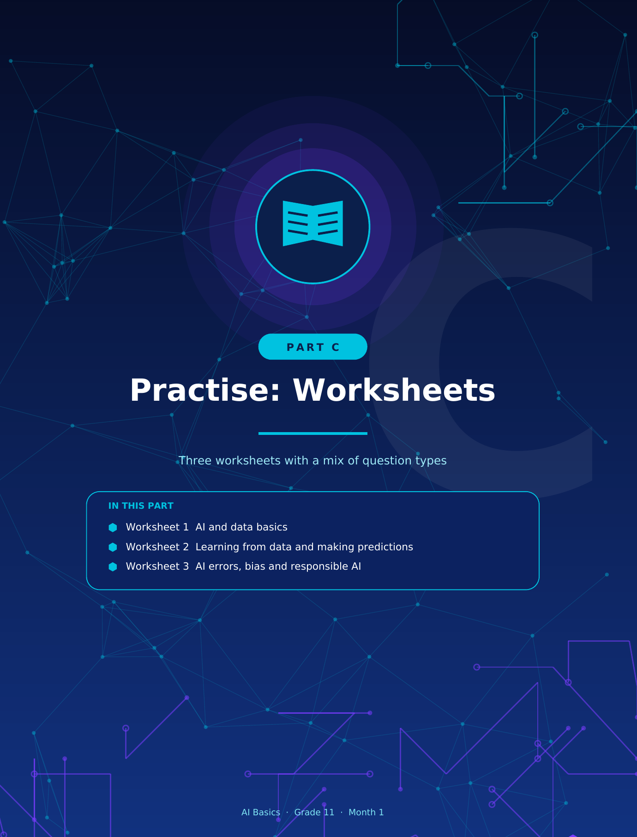

Bas | s
ctio | ____ | ____ | ____ | ____ | _

W1 Worksheet 1: AI and Data Basics
Data, datasets, features, labels and patterns
1. [Fill in the blank] Artificial Intelligence is the ability of a computer system to perform tasks that normally
need human __________.
2. [Fill in the blank] An organised collection of related data, often a table, is called a __________.
3. [Fill in the blank] The correct answer or category attached to an example, such as "cat", is called a
__________.
4. [Fill in the blank] A measurable characteristic of an example, such as colour or weight, is called a
__________.
5. [Matching] Match each term (1-5) with its meaning (A-E). Write the pairs below.
Term | Meaning
1. Data | A. A characteristic of an example that can be measured or described
2. Pattern | B. A program that has learned from data and can make predictions
3. Label | C. Raw facts, numbers, words, images or sounds
4. Feature | D. The answer or category attached to an example
5. AI model | E. Something that repeats or follows a rule in data

Answers: 1 - ____ 2 - ____ 3 - ____ 4 - ____ 5 - ____
6. [True or False] A voice assistant that understands your spoken request uses AI. True / False
7. [True or False] A dataset can only contain numbers. True / False
8. [True or False] Features are the answers that we want the AI to predict. True / False
9. [Short answer] Give two examples of AI you use in daily life and say what data each one uses.

10. [Data interpretation] Study the animal dataset and answer the questions.
ID | Legs | Has wings? | Body covering | Label
1 | 4 | No | Fur | Dog
2 | 2 | Yes | Feathers | Bird
3 | 4 | No | Fur | Cat
4 | 2 | Yes | Feathers | Bird
5 | 4 | No | Fur | Dog
6 | 0 | No | Scales | Fish

(a) How many features are there? Name them.

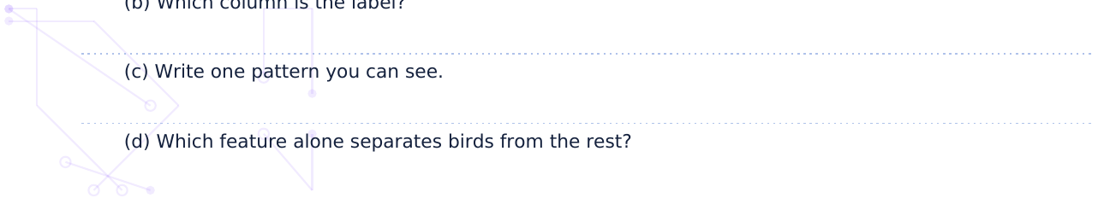

11. [Scenario] A school library app suggests books based on what each student has borrowed. Identify the
data it uses and the output it gives.

12. [Scenario] A phone sorts photos into "Food", "People" and "Pets". What are the labels? Why does it
need many example photos?

13. [Short answer] Which of these are AI and which are not? (a) calculator adding numbers (b) spam filter (c)
ordinary light switch (d) face unlock. Give a reason for each.

a a | ing | ons
/ S | ____ | Date | _____ | ___ | _

1. [Fill in the blank] In machine learning, computers learn by finding __________ in data.
2. [Fill in the blank] The data used to teach a model is called __________ data.
3. [Fill in the blank] Labelled data kept aside to check a model on new cases is called __________ data.
4. [Fill in the blank] The output a trained model gives for a new input is called a __________.
5. [Matching] Match each term (1-5) with its meaning (A-C). Write the pairs below.
Term | Meaning
1. Sorting emails into spam or not spam | A. Classification
2. Suggesting a song you may like | B. Recommendation
3. Estimating tomorrow's temperature | C. Number prediction
4. Labelling a photo as cat or dog
5. "Customers like you also bought..."

Answers: 1 - ____ 2 - ____ 3 - ____ 4 - ____ 5 - ____
6. [True or False] A model should be tested only on the same examples it was trained on. True / False
7. [True or False] More good-quality, varied training examples usually help a model learn better. True /
False
8. [True or False] A trained model always gives correct predictions. True / False
9. [Data interpretation] A model uses the rule: "If hours studied ≥ 3, predict Pass; otherwise predict Fail."
Complete the table and answer.
Student | Hours studied | Actual result | Model prediction | Correct?
S1 | 1 | Fail
S2 | 2 | Fail
S3 | 3 | Pass
S4 | 4 | Pass
S5 | 2.5 | Pass
S6 | 5 | Fail

(a) How many predictions are correct?

(b) Calculate the accuracy.

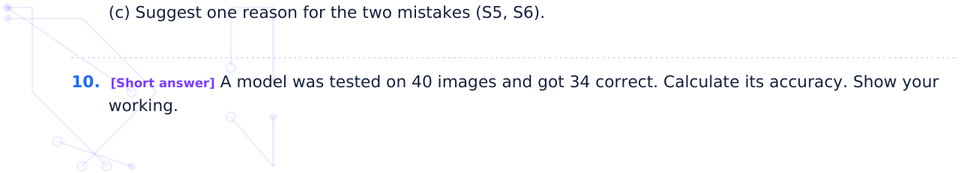

11. [Short answer] Why should we not use the training data to test a model?

12. [Scenario] Arjun wants to build a model to tell ripe from unripe mangoes from photos. State the label,
two possible features and what the training data would be.

13. [Scenario] Maya watched 5 science videos and 1 comedy video. What will a recommendation system
most likely suggest next? Why?

d R | es
n: __ | _____ | ____ | _____

1. [Fill in the blank] A prediction that does not match the real answer is called a prediction __________.
2. [Fill in the blank] Unfairness caused by unbalanced or unrepresentative data is called __________.
3. [Fill in the blank] "Garbage in, garbage out" means poor-quality __________ gives poor results.
4. [Fill in the blank] Keeping personal information protected and under your control is called __________.
5. [Matching] Match each term (1-5) with its meaning (A-E). Write the pairs below.
Term | Meaning
1. A fruit model calls a smooth-skinned orange an apple | A. Sensor readings were wrong (poor-quality data)
2. A crop-disease app fails on photos taken at night | B. Personal data was collected and shared without protection
3. A hiring tool favours one group of applicants | C. Training photos were all taken in bright daylight
4. A weather model is wrong because a sensor broke | D. Training data had no example of this kind
5. A chatbot reveals someone's phone number | E. Past decisions in the data were unfair

Answers: 1 - ____ 2 - ____ 3 - ____ 4 - ____ 5 - ____
6. [True or False] AI is always fair because computers have no feelings. True / False
7. [True or False] Sharing your photos with an app without reading its privacy settings can put your privacy
at risk. True / False
8. [True or False] Humans should be able to review important AI decisions, such as those affecting health.
True / False
9. [Data interpretation] A loan app's model was trained on 100 past applications. Study the data and answer.
Area | Applications in training data
City A | 80
City B | 15
City C | 5

(a) What percentage of the data comes from City A?

(b) Which area is most under-represented?

(c) What may go wrong for people from that area?

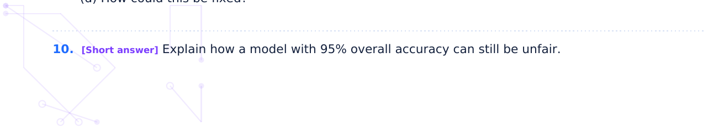

11. [Scenario] A school wants AI cameras to record attendance using students' faces. Give two benefits
and two privacy concerns.

12. [Scenario] A health app's AI suggests a diagnosis. Should the doctor always follow it? Explain.

13. [Short answer] Write three rules for responsible AI use in a school.



Sec | n: _ | Date | _____

D1 Multiple-Choice Questions
30 questions. Circle the one correct option.
1. Which statement best describes Artificial Intelligence?
(A) A machine that only follows fixed steps
(B) A computer system that performs tasks normally needing human intelligence
(C) A device that only stores data
(D) A fast internet connection
2. Which of these is an everyday example of AI?
(A) A torch
(B) A ceiling fan
(C) A paper map
(D) Face unlock on a phone
3. A collection of related data arranged in rows and columns is called a ___.
(A) dataset
(B) label
(C) model
(D) prediction
4. In a dataset of fruits, the word "Apple" attached to a row is the ___.
(A) feature
(B) pattern
(C) label
(D) error
5. Colour, weight and size of a fruit are examples of ___.
(A) labels
(B) predictions
(C) features
(D) models
6. Something that repeats or follows a rule in data is a ___.
(A) pattern
(B) password
(C) pixel
(D) bug
7. Machine learning means that computers ___.
(A) are given every rule by hand
(B) never use data
(C) only work on the internet
(D) learn patterns from data examples
8. Data used to teach a model is called ___ data.
(A) testing
(B) training
(C) random
(D) final
9. Why is testing data kept separate from training data?
(A) To save storage space
(B) To make training faster
(C) To check how the model handles new examples (D) To delete errors
10. The output a model gives for new input is a ___.
(A) prediction
(B) dataset
(C) feature
(D) sensor
11. A trained program that uses learned patterns to make predictions is a(n) ___.
(A) spreadsheet
(B) label
(C) circuit
(D) AI model
12. A spam filter sorting emails into "spam" or "not spam" is an example of ___.
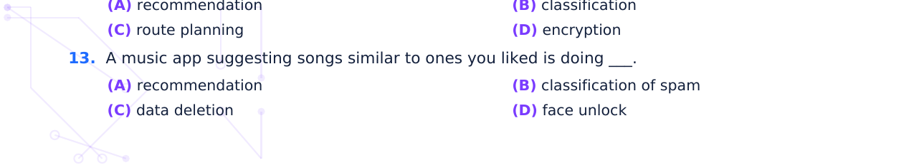

14. Predicting tomorrow's rainfall in millimetres is an example of ___.
(A) classification only
(B) recommendation
(C) number prediction
(D) labelling
15. A model correctly predicts 18 of 20 test items. Its accuracy is ___.
(A) 18%
(B) 90%
(C) 80%
(D) 98%
16. A model gets 45 of 60 test items right. Its accuracy is ___.
(A) 45%
(B) 80%
(C) 15%
(D) 75%
17. Which would most likely reduce a model's errors?
(A) Using fewer examples
(B) Testing only on training data
(C) More good-quality, varied training data
(D) Removing all labels
18. "Garbage in, garbage out" means ___.
(A) poor data leads to poor predictions
(B) AI collects rubbish
(C) more data is always worse
(D) AI cleans its own data
19. In the fruit example, a smooth-skinned orange was predicted to be an apple. The main reason was that
___.
(A) oranges are always bigger
(B) the computer was too fast
(C) apples are always red
(D) the training data had no smooth oranges
20. Bias in AI most often comes from ___.
(A) too much electricity
(B) unbalanced or unfair data
(C) screen size
(D) fast internet
21. A face-unlock tool works well for some groups of people but poorly for others. The most likely cause is
that ___.
(A) training data lacked enough examples from
(B) faces change with age
every group
(C) the phone was old
(D) light affects only people
22. Which is a privacy risk?
(A) Using strong passwords
(B) Reading privacy settings
(C) Sharing personal photos with an app without (D) Updating software
checking its permissions
23. Responsible AI means AI that is ___.
(A) as fast as possible
(B) secret
(C) cheapest
(D) fair, transparent, private, safe and accountable
24. In a dataset for predicting house price, which column is the label?
(A) Number of rooms
(B) Price
(C) Location
(D) Area
25. Farmers use an app to check leaf photos for disease. This is AI in ___.
(A) transport
(B) agriculture
(C) marine science
(D) entertainment
26. Using AI to identify fish species in underwater video belongs to ___.
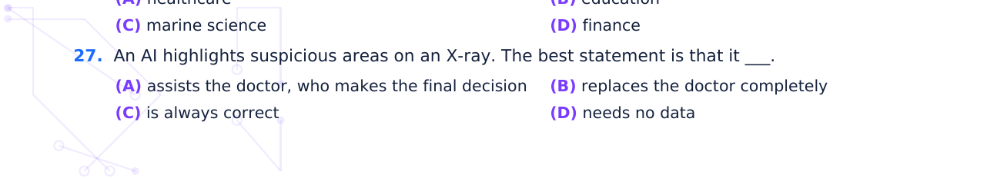

28. Which statement about accuracy is correct?
(A) 100% on training data guarantees success on (B) It is the number of features
new data
(C) Low accuracy means a good model
(D) It should be measured on testing data
29. A navigation app predicts jams using past speed data. The pattern it uses is that ___.
(A) car colour affects traffic
(B) phone brands affect speed
(C) the same roads are usually slow at the same (D) road names are alphabetical
times
30. Which step comes right after training a model in the ML cycle?
(A) Test and evaluate it
(B) Collect data
(C) Delete data
(D) Choose the label

_____ | ____ | _____

D2 Quick Quiz
10 questions, 10 marks, 10 minutes
1. The answer attached to an example in a dataset is called a __________.
2. Machine learning systems learn from examples. True / False
3. Which of these is a feature of a fruit?
(A) The word "Banana" written as the answer
(B) The accuracy of the model
(C) The name of the app
(D) Diameter in cm
4. Testing a model only on its training examples gives a fair measure of performance. True / False
5. A model gets 24 of 30 test items right. Its accuracy is ___.
(A) 24%
(B) 30%
(C) 80%
(D) 6%
6. Bias can come from unbalanced data. True / False
7. A music app suggests songs you may like. This task is ___.
(A) spam detection
(B) recommendation
(C) data deletion
(D) face unlock
8. Poor-quality __________ leads to poor predictions ("garbage in, garbage out").
9. Which action best protects privacy?
(A) Posting your passwords
(B) Accepting every permission without reading
(C) Sharing only the data an app really needs
(D) Using one password everywhere
10. A responsible AI system should be fair and transparent. True / False
Score: ______ / 10

D | ____
ng  ks. | ons

D3 Chapter 1 Assessment
Total: 30 marks · Time: 45 minutes
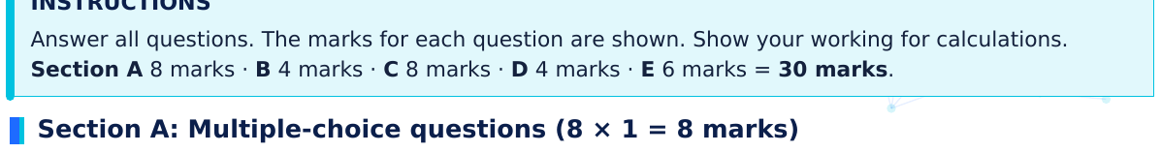
1. In a dataset of animal photos, the word "Dog" attached to a dog photo is a ___. [1 mark]
(A) feature
(B) label
(C) model
(D) prediction
2. Which is NOT an example of AI? [1 mark]
(A) A voice assistant understanding speech
(B) A photo app grouping faces
(C) A translation app
(D) A calculator adding 2 + 3 by fixed rules
3. Machine learning is best described as a way for computers to ___. [1 mark]
(A) learn patterns from data
(B) follow only hand-written rules for every case
(C) work without any data
(D) work only offline
4. The purpose of testing data is to ___. [1 mark]
(A) teach the model its first patterns
(B) increase the number of features
(C) check how well the model works on new
(D) store the labels safely
examples
5. Which sequence of steps is correct? [1 mark]
(A) Collect data → Train → Test → Improve
(B) Test → Collect data → Train → Improve
(C) Train → Collect data → Test → Improve
(D) Improve → Train → Collect data → Test
6. A model scores 90% on training data but 55% on testing data. The best conclusion is that it ___. [1 mark]
(A) is perfect
(B) needs no improvement
(C) has wrong testing data by definition
(D) may have memorised the training examples and does not work well on new ones
7. A model is correct on 27 of 30 test items. Its accuracy is ___. [1 mark]
(A) 27%
(B) 3%
(C) 90%
(D) 81%
8. A crop-disease app trained only on tomato-leaf photos is used on potato leaves. The best expectation is
___. [1 mark]
(A) perfect accuracy
(B) lower accuracy, because potato leaves were not in the training data
(C) that it will refuse to run
(D) that it will learn potatoes instantly

Section B: Fill in the blanks (4 × 1 = 4 marks)
9. The measurable properties used to describe each example, such as weight or colour, are called
__________. [1 mark]
10. A prediction that does not match the real answer is a prediction __________. [1 mark]
11. Data used to teach the model is called __________ data. [1 mark]
12. Unfairness caused by unbalanced or unrepresentative data is called __________. [1 mark]

Section C: Short answers (4 × 2 = 8 marks)
13. Define Artificial Intelligence and give one everyday example. [2 marks]

14. State one difference between training data and testing data. [2 marks]

15. Why can poor data quality lead to wrong predictions? Give one example. [2 marks]

16. State two ways to make AI more responsible. [2 marks]

Section D: Data interpretation (4 marks)
17. A fruit classifier was tested on 10 fruits. The table shows the results.
No. | 1 | 2 | 3 | 4 | 5 | 6 | 7 | 8 | 9 | 10
Actual | Apple | Apple | Banana | Banana | Orange | Orange | Apple | Banana | Orange | Apple
Predicted | Apple | Apple | Banana | Banana | Orange | Apple | Apple | Banana | Orange | Orange

(a) How many predictions were correct? [1 mark]

(b) Calculate the accuracy. [1 mark]

(c) Which fruit was wrongly predicted as an Apple? [1 mark]

(d) Suggest one way to improve the model. [1 mark]

Section E: Application questions (2 × 3 = 6 marks)
18. A school wants an AI system to suggest library books to students.
(i) Name one type of data it would need. [1]

(ii) State one pattern the AI could use. [1]

(iii) State one privacy concern. [1]

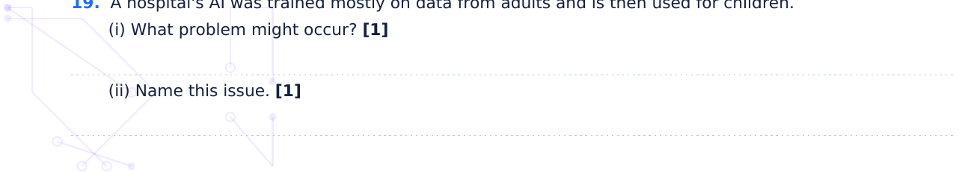

(iii) Suggest one solution. [1]

Total marks obtained: ______ / 30

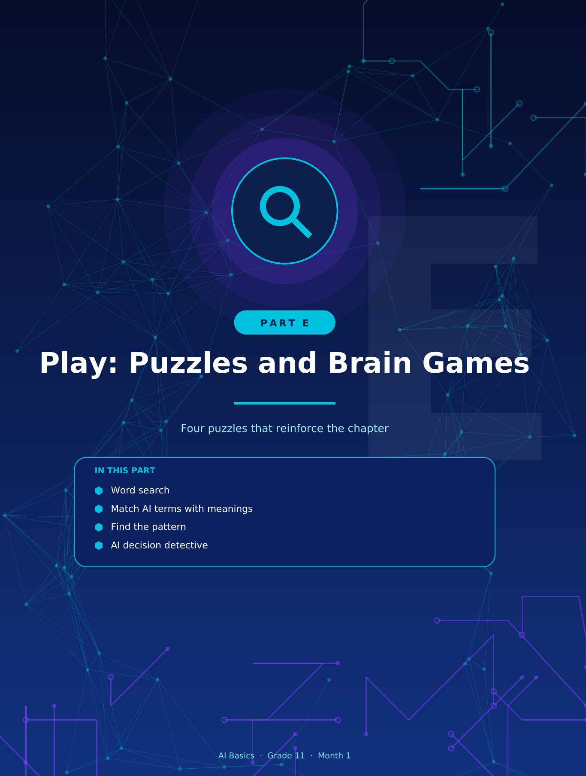

e 1  hidd | at | S | ear
____ |  | ctio | n: __ |  | Date | ____ | ____
rds  ch w | dow  the | ally | (top | otto | righ | ; a | are
A | U | O | L | D | P
P | J | H | M | C | R
F | I | E | N | W | I
N | H | E | C | H | V
V | S | F | I | E | A
N | N | S | K | Q | C
T | X | B | O | Z | Y
R | M | D | P | M | B
G | O | D | R | B | D
A | R | S | E | L | T
A | B | S | D | U | I
L | D | O | I | J | C
E | E | X | C | I | P
W | F | G | T | E | W

E1 Puzzle 1: AI and Data Word Search
Find the 12 hidden words
☐ DATA | ☐ LABEL | ☐ MODEL | ☐ FEATURE
☐ PATTERN | ☐ TRAIN | ☐ TEST | ☐ LEARN
☐ BIAS | ☐ PRIVACY | ☐ ACCURACY | ☐ PREDICT

BONUS
Pick any three of the words and write a one-line definition for each.

th | Th | heir | ani
ctio | n: __ | _____ | D
. Ea | ch m | mean | sed
el gi | es fo | or a | t
attac | hed | to an | e
orm | tion | n pro | nd un
ion | f rela | ated | ten a
s a | erce | entag | predi
mple | s use | ed to | he m
cter | tic o | of an | e (an
ss, o | ten | caus | nbala
e m | del | learn
es: | atter | rns u | make

E2 Puzzle 2: Match AI Terms with Their Meanings
Write the correct letter in the box
Score: ______ / 10

3 | ha | en
e: __ | ion | ____ | D | _____ | ___

E3 Puzzle 3: Find the Pattern Challenge
Spot the rule, then predict what comes next
Instructions: Find the pattern in each item and write the missing answer. Then write the rule in words. Spotting patterns is exactly what machine learning does!
1. 2, 4, 8, 16, ____
Answer: ________________ Rule: ________________________________________________
2. 3, 6, 9, 12, ____
Answer: ________________ Rule: ________________________________________________
3. 1, 4, 9, 16, 25, ____
Answer: ________________ Rule: ________________________________________________
4. A, C, E, G, ____
Answer: ________________ Rule: ________________________________________________
5. Coloured boxes (see the picture): blue, cyan, violet, blue, cyan, violet, blue, ?
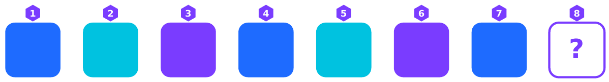
Answer: ________________ Rule: ________________________________________________
6. Rainfall → umbrellas sold: 0 mm → 0, 5 mm → 10, 10 mm → 20, 15 mm → 30. For 20 mm → ____
Answer: ________________ Rule: ________________________________________________
7. Fruit rules: Long → Banana. Round and Bumpy → Orange. Round and Smooth → Apple. Predict: Long,
yellow, smooth → ____
Answer: ________________ Rule: ________________________________________________
8. 1, 1, 2, 3, 5, 8, ____
Answer: ________________ Rule: ________________________________________________
CHALLENGE
Create your own pattern puzzle with a rule, write it below and ask a friend to solve it.

ct
Sec | ____ | _____
fin | the | e AI

E4 Puzzle 4: AI Decision Detective
Use the data clues to solve four cases
A bus company records six days. Clue: look for the feature that always matches the label.
Day | Rain? | Roadwork? | School bus
1 | Yes | Yes | Late
2 | Yes | No | On time
3 | No | Yes | Late
4 | No | No | On time
5 | Yes | Yes | Late
6 | No | No | On time

1a. Which feature decides whether the bus is late?

1b. Today: Rain = Yes, Roadwork = No. Predict the bus status.

1c. Which feature is a "red herring" (not useful)?

Case 2: The Spam Detective
Use the spam-points rules from section A5 (spam if 3 or more points): "WIN FREE PRIZE" +2, unknown sender +1, many links +1, saved contact −2.
Email | Says "WIN FREE PRIZE"? | Sender | Number of links | Label
X | Yes | Unknown | 5 | ?
Y | No | Teacher (saved contact) | 0 | ?

2a. Calculate the points for Email X and Email Y.

2b. Label each email.

Case 3: The Playlist Detective
A music app studies Meena's week of listening.
Type of song | Times played this week
Pop | 9
Classical | 1
Rock | 2
Folk | 0

3a. Which type will the app most likely recommend first? Why?

cted
lthy
ased
lthy
lthy
lthy
lthy
ased
lthy

4a. Calculate the accuracy.

4b. What do all the mistakes have in common?

4c. Suggest what the training data probably lacked, and how to fix it.



____

F1 Case Study 1: The Leaf Doctor
Agriculture · an illustrative case based on real kinds of systems
THE SITUATION
In a rice-growing region, farmers often notice spots on leaves but cannot tell which disease it is, and visiting an expert takes days. A team builds a phone app: the farmer photographs a leaf and the app suggests whether it is Healthy, Blast disease or Leaf spot.

How the AI was built
Step | What the team did
Data | 3,000 leaf photos, each labelled by plant experts as Healthy, Blast or Leaf spot
Features | Colour, shape and position of spots, leaf edges and texture found in the images
Training and testing | 2,400 photos for training (80%) and 600 for testing (20%)
Result | On the 600 test photos the model was right 534 times
Field trial | On photos taken by farmers on cloudy days and with dirty leaves, accuracy was only about 70%

Questions
1. Calculate the model's accuracy on the test photos. Show your working.

2. Why did accuracy drop in the field trial? Link your answer to data quality or variety.

3. Suggest two improvements the team should make.

4. Identify one ethical or practical concern (for example privacy, trust, cost, language) and how to
handle it.

ta | anc
ta | anc
ecti | D | ____ | ____
era  en t  est  any  t hi  y st | e-an  inne  ntain  erim  hich | pro  n. O  r fe  AI  avo | am  r  l to  ed m

F2 Case Study 2: When the Data Is Unbalanced
Fairness · based on real reported research and news

What the examples teach
Problem | Type of bias | How it happened
Higher errors for some faces | Unbalanced (unrepresentative) data | Too few examples of some groups
Recruiting tool favouring men | Historical bias | Learned from past unfair human decisions

Questions
1. In your own words, explain why an AI can be unfair even though a computer has no feelings.

2. A face system is 98% accurate overall, but only 70% accurate for one group. Why is the overall figure
misleading?

3. Suggest three actions the builders should take to make these systems fairer.

4. Should an AI recruiting tool make hiring decisions alone? Give reasons.

____
mun
nsib

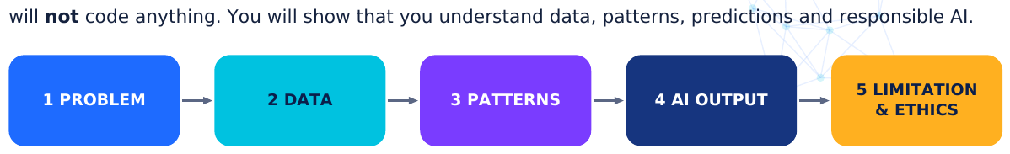
Figure F.1 The five parts of your design.
Worked example (for ideas only)
Part
Example: "Canteen Rush Predictor"
1 Problem
Long queues in the canteen at some break times; food runs out.
Past 30 days: number of students buying, day of week, weather, whether there was a sports
2 Data
event.
3 Patterns
More students buy on rainy days and on Mondays; fewer on sports-event days.
4 AI output
Predicts the number of students (a number) and recommends how many meals to prepare.
5 Limitation /
Predictions can be wrong on unusual days; the data must not record individual students'
ethics
purchases.

Your project
Title of my AI system: ____________________________________________
Part 1: Identify a problem. What problem will the system help solve? Who is affected?

Part 2: Select suitable data. List the data you need. Which are features? Which is the label or number to predict? Where will the data come from?

Part 3: Describe the patterns. What patterns might the AI find? Give at least two.

Part 4: Propose the AI output. What will the system produce (a classification, a recommendation or a number)? What decision will it support?

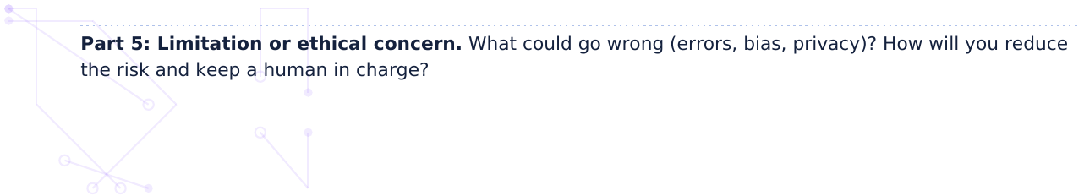

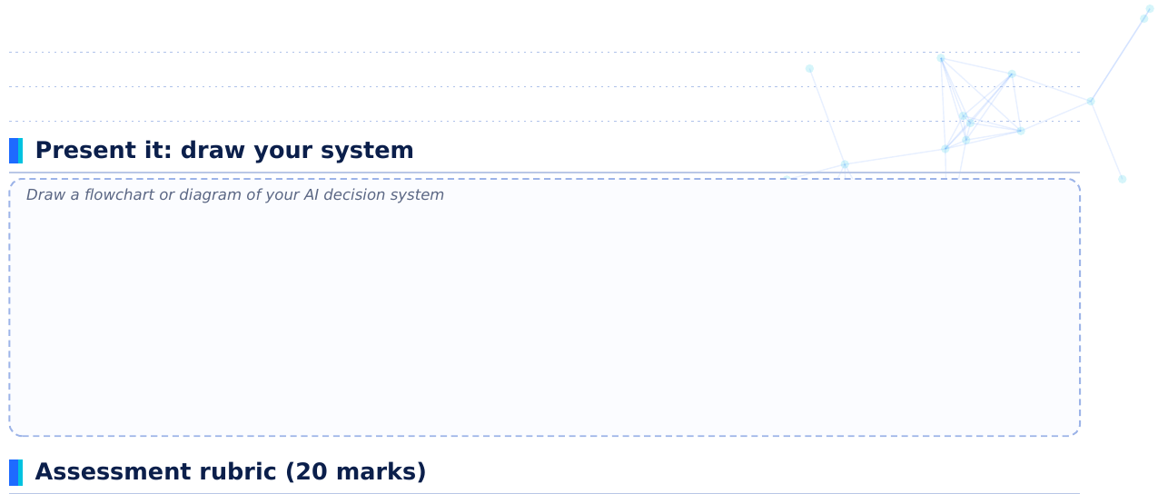
Criterion | 4 marks | 3 marks | 2 marks | 1 mark
Problem | Clear, realistic and specific | Clear but general | Vague | Unclear
Data | Features and label/number named; source realistic | Features named, label unclear | Data listed without features | Irrelevant data
Patterns | 2+ sensible patterns tied to data | One sensible pattern | Pattern unclear | No pattern
AI output | Output type clear and linked to a decision | Output stated | Output unclear | Missing
Limitation / ethics | Specific risk and sensible response | Specific risk named | Generic risk | Missing

sti | on | ns
ctio | n: __ | _____ | ____ | ____
a gr | en b | bana | and | d wh | hat

F4 Higher-Order Thinking Questions
Analyse, evaluate and create

2. Two models: Model X is 95% accurate on training data and 60% on testing data. Model Y is 80% on both.
Which would you trust? Why? [3 marks]

3. A hospital model detects a rare disease. It is 99% accurate, but it misses half the patients who have it.
How is that possible, and what should the hospital check? [4 marks]

4. Design a feature list for an AI that predicts whether a student will be late to school. Then identify one
feature that could be unfair or invade privacy. [4 marks]

5. "AI does not make mistakes because it is a computer." Argue against this statement with two examples
from this chapter. [4 marks]

6. A recommendation system only shows you videos similar to what you have already watched. What could
be the downside over time? [3 marks]

7. You are given a dataset with 90 photos of cats and 10 of dogs. A model labels every photo "cat" and is
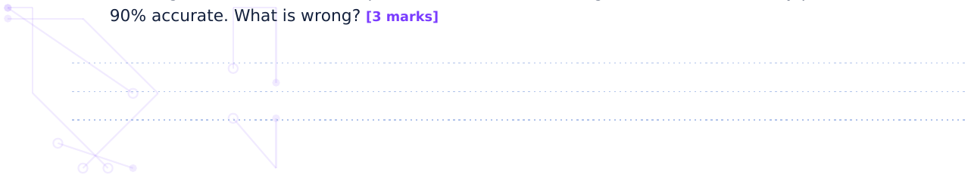

8. Should a school allow an AI to decide who gets a scholarship without human review? Give a reasoned
answer with two points. [4 marks]

____ | ____ | ____

F5 Revision Exercises
Check, fix and recall
1. The ________ is what we want an AI to predict.
2. The inputs that describe each example are called ________.
3. The ________ cycle ends with improving the model and training again.
4. Accuracy = correct ÷ ________ × 100.
5. A model that sorts items into groups performs ________.
6. Data kept aside to check the model is ________ data.

B. True or false (correct the false ones)
7. A model with 100% training accuracy is always good on new data. True / False

8. Privacy means protecting personal data. True / False

9. Bias in AI always comes from the programmer's opinions. True / False

10. A recommendation is a type of prediction about what you may like. True / False

C. Spot the mistake
11. "Our model got 8 of 10 right, so its accuracy is 8%."

12. "The features are the answers the AI must predict."

13. "We test the model with the same photos we trained it on, because that is fair."

D. Mind-map recall
Without looking at your notes, write as many words as you can under each heading.
Data | Learning | Prediction | Responsible AI

D | Date | _____

F6 Student Reflection Page
Think about your learning

The most interesting example of AI I came across was... because...

One thing that is still confusing is...

One way I will use AI responsibly is...

A question I would like to explore next:

How confident do I feel? (circle one) 1 2 3 4 5

____ | ____
ot y | ere
☐
☐
☐
☐
☐
☐
☐
☐
☐
☐
☐
☐

F7 Self-Assessment Checklist
Tick how well you can do each skill
My goal for next time:

Teacher comment:

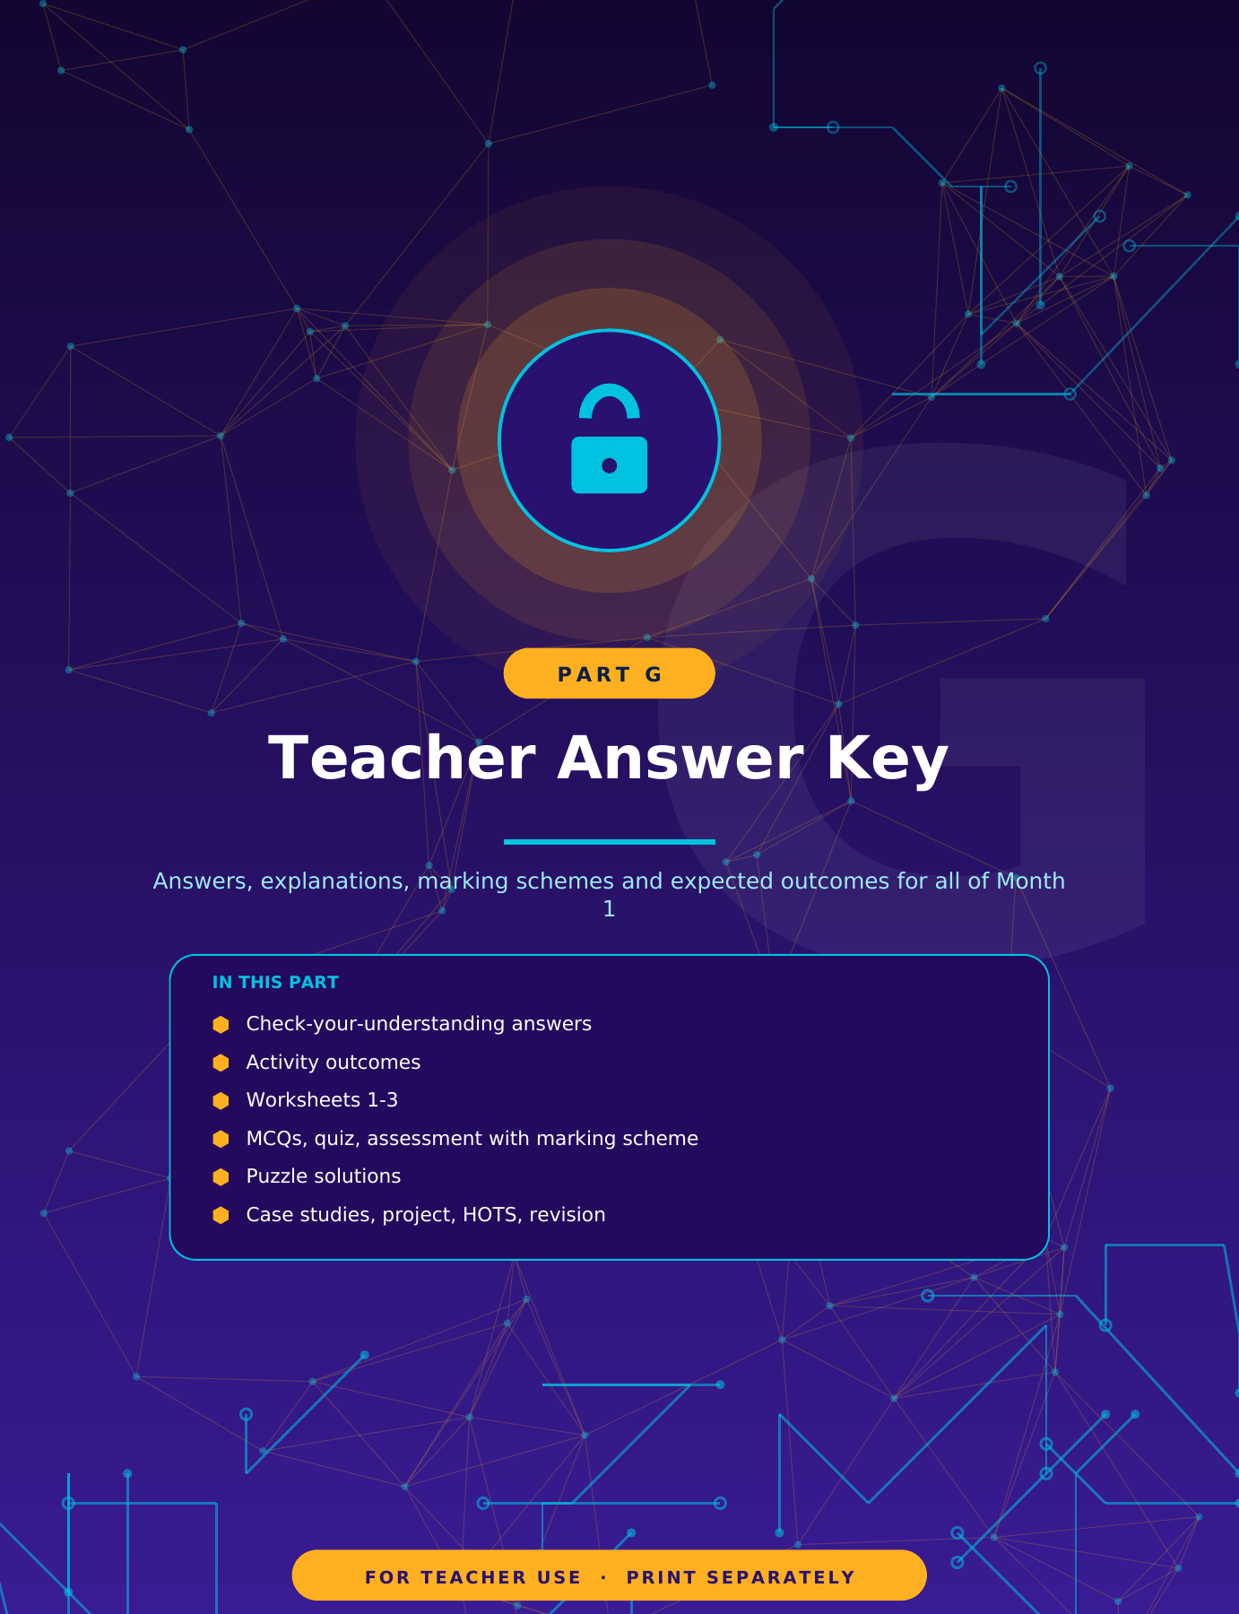

anat
in M

K-0 Teacher Guide and Contents of the Key
How to use this answer key
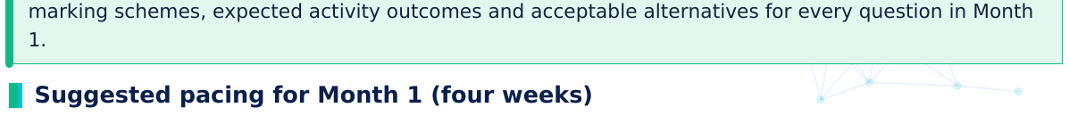
Week | Teach (Part A) | Do (Parts B, C)
1 | A1 What is AI; A2 Data and datasets | Activity 1; Activity 2; Worksheet 1
2 | A3 Machine learning; A4 Training, testing, models | Activity 3; Worksheet 2
3 | A5 Choices; A6 Fruit example; A7 Accuracy and data quality | Activity 5; puzzles
4 | A8 Bias and privacy; A9 Applications; A10 Summary | Activity 4; case studies; mini-project; Quiz and Assessment

Contents of this key
Section | Covers
K-A | Answers to the "Check Your Understanding" questions in the notes (A1 to A10)
K-B | Expected activity outcomes and model flowcharts (Activities 1-5)
K-C | Worksheets 1-3
K-D | MCQs (30), Quick Quiz (10), Assessment (30 marks)
K-E | Puzzle solutions
K-F | Case studies, mini-project guidance, HOTS and revision answers

MARKING PRINCIPLES
Award marks for correct ideas, not exact wording. Accept any valid example. Follow-through marks apply for calculations that use a correct method with a slip in arithmetic.

di
orm oice | d hum t, sp | e.g. ugge | eco tion
orre dict | ion, ord) | men | atio
from | r ad | ce.
our | is t | we | ant
e; st | who | ore | ighe
e be | dictio | gram | mer
ta; M | s ma | suit | com
mple | g on | uld o | ly s
oto | fterw | esti | g da
dicti
is t | est r
ang esti | e m .) | t sm | ooth
dat | /mis | w sit | atio
edic | g., a | d w | h
ata h | ew e | gro | ps, o
ong | pass | adin | oth
y; a | can u | tice | error
pat | d ou | ture | eaf
owle | d tak | or t | e fin
a mo | ed e | less | accu

K-A Key: Check Your Understanding
Answers for sections A1 to A10
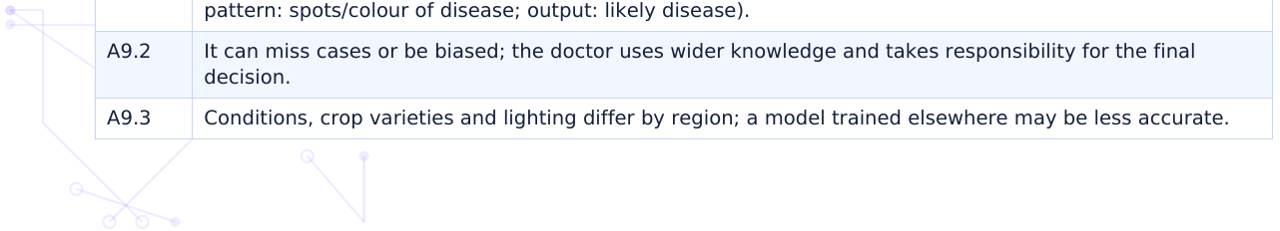

K-B Key: Activities
Expected outcomes and model answers
rule "wings = bird" fails for bats. Q2: putting the "fur" rule before the "wings" rule fixes the bat for these 10 cards, but rules written from a few examples can still fail on other animals (for example, a platypus has fur but lays eggs). Accept thoughtful answers.
Activity 2: Mini dataset. Check: at least 10 rows, 3 features, 1 label, consistent units, no missing values. Sample patterns: writing tools (pens, pencils, markers) are long and thin; erasers and sharpeners are short. Colour is not useful. Data-quality problems might include inconsistent units, missing entries, unclear materials.
Activity 3: Classroom classifier. Rule: warm colours (red, orange, yellow) = SUN; cool colours (blue, green, purple) = MOON. Irrelevant features: shape and size. Test answers: T1 Sun, T2 Moon, T3 Sun, T4 Moon, T5 Sun, T6 Moon. Typical round-1 accuracy 5/6 = 83% (T6 guessed wrongly) or 6/6 = 100% if guessed Moon. After the extra cards: 6/6 = 100%.
Activity 4: Bias. Percentages: Boys 90%, Girls 10%; City 85%, Village 15%; Football 75%, Running 15%, Kabaddi 10%. Under-represented: girls, village schools, running and kabaddi. Pattern: past selections were all city boys, mostly footballers. Rule: "city + boy + football = selected". Unfair outcomes: girls and village students overlooked; non-football talents ignored. Fair plan: collect more records from under-represented groups, include more sports, test accuracy separately per group, keep human review, obtain consent and protect privacy.
Activity 5: Flowchart. Model flowchart for Task A is shown below.
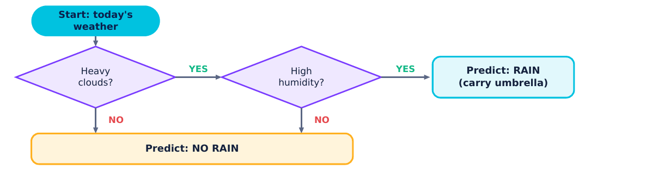
Model answer for Task A
Rubric (10 marks): symbols used correctly 4; logic and every path ending in an output 3; testing with three scenarios 3. Task B is open: check for questions in diamonds, labelled yes/no arrows, outputs on all paths.

W1
An
int
da
lab
fea
1-C
Tr
Fa
Fa
Op (vi | ds), | o a
(a) (b) (c) Do (d) | th 4 | s =
Da | mme | tion
La | ch c | gory
(a) fac | (d) | eco

K-W1 Key: Worksheet 1: AI and Data Basics
Answers and acceptable alternatives

W2
An
pa
tra
tes
pre
1-A
Fa
Tr
Fa
(a) (b) (c) stu | unw
34
It w wo | the
La ph | d ma
Mo | 5 of

W3 | ibl | e A | AI
An
err
bia
da
pri
1-D
Fa
Tr
Tr
(a) (b) (c) (d) | ew rea | xam | mples
Th for | s m | ch w | worse | form
Be mi | nal | ata; r | risk | aks
No acc | judg | men | nt an | ma
Op a h | rnes | acro | oss g | ps. | p

hat at p | huma orma | an ally n
es. C | ace u | unlo
Corre | et.
orre
l's i | ption | n: fe
ect
onl | ules. | . Cor
Corr | ng.
real mple | atter | rn. C
rrec | ion.
AI m
ion:
ect | enda | ation
edic
elia | rrect | t opt
po | poor | r pre
it a moot | d sm | moot
rec | nced | d or u
urac | n: tra | ainin
ect | pers | sona
opt | arent | t, pri
ct op
rect | ure.
e.
ptio | ctor, | , wh
It sh | ed o | on te
It sh | ed o | on te
t op | oads | s are
on: | e it. | .

K-D1 Key: Multiple-Choice Questions
Answers with explanations
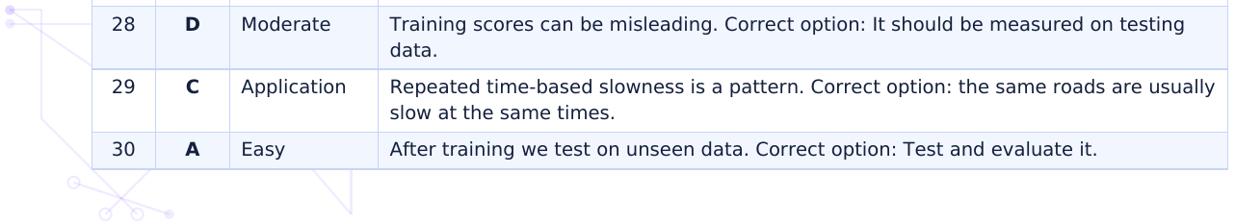

Level mix: 13 easy, 11 moderate, 6 application-based.

K-D2 Key: Quick Quiz
1 mark per question
Total: 10 marks. Award 1 mark for each correct answer; no half marks.

D3 | ma | )
An |  |  | Ma | L | Leve
B ( |  |  | 1 | E | Easy
D ( |  |  | 1 | E | Easy
A ( |  |  | 1 | E | Easy
C ( |  |  | 1 | M | Mode
A ( |  |  | 1 | M | Mode
D ( on | ell o |  | 1 | M | Mode
C ( |  |  | 1 | A | Applic
B ( | ata) |  | 1 | A | Applic
fea |  |  | 1 | E | Easy
err |  |  | 1 | E | Easy
tra |  |  | 1 | E | Easy
bia |  |  | 1 | E | Easy
De Va | inte | (1). | 2 | M | Mode
Tra ch | de, u | o | 2 | M | Mode
Th Ex | ed t (1). |  | 2 | M | Mode
An pri | grou ent a | ect its. | 2 | M | Mode
(a) (b) (c) (d) ali | es th |  | 4 | A | Applic
(i) bo sim mi | ) Stu dent sha | ho | 3 | A | Applic
(i) un ch | pre par | e / | 3 | A | Applic

K-D3 Key: Chapter 1 Assessment (30 marks)
Answers and marking scheme
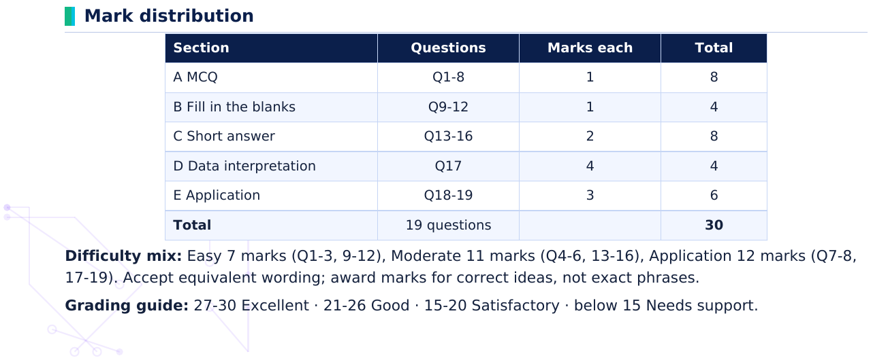
Section | Questions | Marks each
A MCQ | Q1-8 | 1
B Fill in the blanks | Q9-12 | 1
C Short answer | Q13-16 | 2
D Data interpretation | Q17 | 4
E Application | Q18-19 | 3
Total | 19 questions

Pu  h, m | on  dete
se | (hi | )
A | U | O | L | F | T | D | P
P | J | H | M | M | P | C | R
F | I | E | N | R | I | W | I
N | H | E | C | F | E | H | V
V | S | F | I | J | A | E | A
N | N | S | K | E | W | Q | C
T | X | B | O | Y | V | Z | Y
R | M | D | P | P | U | M | B
G | O | D | R | K | T | B | D
A | R | S | E | T | D | L | T
A | B | S | D | M | E | U | I
L | D | O | I | P | P | J | C
E | E | X | C | K | X | I | P
W | F | G | T | Q | L | E | W

K-E1 Key: Puzzle Solutions
Word search, matching, patterns and detective cases
Word | Start (row, col) | Direction
DATA | (14, 2) | across →
LABEL | (6, 5) | down ↓
MODEL | (13, 3) | across →
FEATURE | (1, 2) | across →
PATTERN | (7, 2) | down ↓
TRAIN | (2, 2) | diagonal ↘
TEST | (10, 11) | backwards ←
LEARN | (3, 8) | down ↓
BIAS | (11, 6) | across →
PRIVACY | (1, 14) | down ↓
ACCURACY | (3, 7) | down ↓
PREDICT | (8, 10) | down ↓

Puzzle 2: Matching
Term | Letter | Term | Letter
1. Dataset | D | 6. Model | J
2. Feature | G | 7. Prediction | A
3. Label | B | 8. Accuracy | E
4. Training data | I | 9. Bias | H
5. Testing data | F | 10. Privacy | C

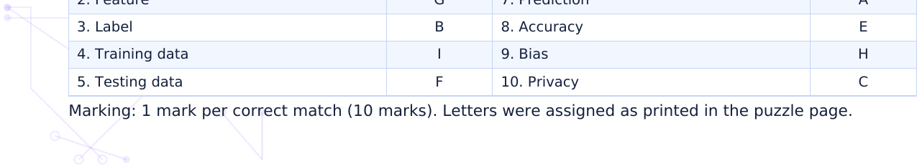

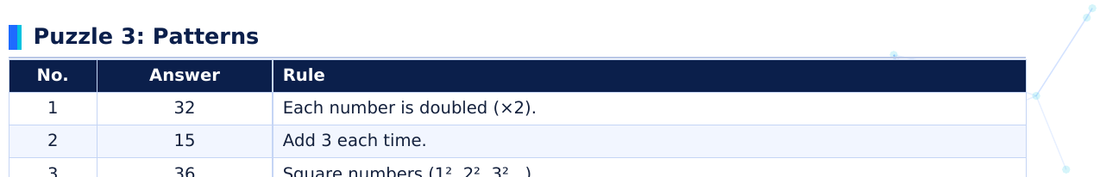
No. | Answer | Rule
1 | 32 | Each number is doubled (×2).
2 | 15 | Add 3 each time.
3 | 36 | Square numbers (1², 2², 3²...).
4 | I | Skip one letter each time.
5 | Cyan | The three colours repeat in a cycle of three.
6 | 40 | 2 umbrellas for every 1 mm of rain.
7 | Banana | The first rule (Long) applies.
8 | 13 | Each number is the sum of the previous two (5 + 8).

Puzzle 4: Detective cases
Case 1: (a) Roadwork (Late every time roadwork = Yes). (b) On time. (c) Rain.
Case 2: (a) X: 2 + 1 + 1 = 4 points. Y: −2 points (no other clues). (b) X = Spam; Y = Not spam.
Case 3: (a) Pop: it is her most-played type (strongest pattern). (b) 9 ÷ 12 × 100 = 75%.
Case 4: (a) 5 ÷ 8 × 100 = 62.5%. (b) All errors are diseased leaves photographed in shade, predicted "Healthy". (c) Training data probably had few or no shaded photos of diseased leaves; add varied lighting examples and retest.

F1
Stu
An
53
Th we | ays varie | dirt a qu
An tes | mples | dis
Ex loc | nfirm ith a | /dat res

K-F1 Key: Case Studies
Model answers
Case Study 2: When the Data Is Unbalanced
Q | Answer
1 | AI learns from data made by people. If the data is unbalanced or reflects past unfair choices, the model copies those patterns. The unfairness comes from data and design, not from feelings.
2 | Overall accuracy averages everyone together; the large well-represented group hides the poor performance on the small group.
3 | Any three: collect more balanced data; test accuracy for each group separately; audit and fix biased labels; involve diverse reviewers; be open about limits; keep human oversight.
4 | No. Important decisions affecting people's opportunities need human review and accountability; AI can assist but may repeat bias. Accept reasoned answers.

K-F3 Key: Mini-Project Guidance
Teacher notes and marking
supports (not replaces) a human decision; a specific limitation (data too small, unbalanced, privacy, wrong predictions).
Marking: 5 criteria × 4 marks = 20 marks (see rubric on the student page). Accept any topic. Do not penalise spelling.
Common weaknesses: choosing a problem that needs no data; features that cannot be measured; confusing the feature with the label; "no limitations". Prompt students with: What if the data is missing one group? What if it is wrong on a bad day?

m. A | Add | sha | d) or
ning | g da | ata a | erali | rms
alm d, no | most ot o | t ev only | acc | e ho
ake- ess s | -up sen | tim nsitiv | hom | s or
r bi un | iase nder | ed; e r-rep | h ora | ed a
ne | ew id | deas | hab | ow v
hing rors | g ab s pe | bout er cl | hide | ls a
by ept | pas t we | st da ell-re | erve ves. | on a

K-F4 Key: HOTS and Revision
Model answers
Revisi on | Answer
1 | label
2 | features
3 | machine learning
4 | total predictions
5 | classification
6 | testing
7 | False. It may have memorised the examples.
8 | True.
9 | False. It often comes from the data.
10 | True.
11 | Accuracy = 8 ÷ 10 × 100 = 80%.
12 | The labels are the answers; features are the inputs.
13 | Testing must use new, unseen data.
D | Open. Look for: dataset, feature, label, pattern; training, testing, model, accuracy; classification, recommendation, error; bias, privacy, fairness.

